**Foot Hand Ear Reflexology**

**Two Power Packed Workshops with Bill Flocco**

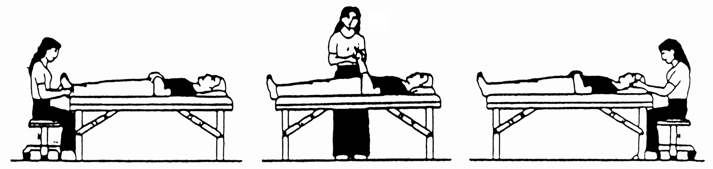

|  |  |
| --- | --- |
| **Pain Control & Stress Reduction**  **With Foot Hand Ear Reflexology**  **For Beginners & Professional**  **\* 3 CE Hours: ARCB, NCBTMB, ABMP, many States**  During this powerful Hands-on Workshop, discover how to achieve ***profound stress reduction*** as well as pain relief, using gentle finger and thumb pressure on ears, hands and feet for relief of the following common health challenges:   * Allergies * Headaches, Sinusitis, Jaw, Neck * Heartburn, Stomach (Acid Reflex) * Colon (Colitis) * Sleep Disorders * Poor Nutrient Absorption, and more.   **\*\*\* Please Note:** **This is mostly a different body of knowledge from Saturday–Sunday. A powerful addition to the weekend!**  **When: Friday Evening, September 7, 2018**  **Where:**  Comfort Suites Hotel  70 Chris Perry Lane, Columbus, Ohio 43213  Room Reservations 614 604-6400  **Time:** 6:00 PM - 9:00 PM  **Fee:** $60 by August 7th $75 thereafter  Full refund if notified by August 31st | **EAR REFLEXOLOGY *14 CE Hours**  **Body Map, Master Points & Functional Points**  **Prerequisite: Beginning Foot Reflexology**  **\* 14 CE Hours: ARCB, NCBTMB, ABMP & many States**  The ears are amazing for rapid profound relaxation, and remarkable for jaw, neck, all ten zones of the shoulders, all ten zones of the lower back, lumbar spine, sacrum, coccyx, hip, and sciatica.  Perform a half hour ear reflexology routine, perform protocols for: addictive behaviors, drug withdrawal, pain in upper & lower limbs, head & neck pain, spinal & sciatic pain, stress related disorders, dental pain, psychological disorders  **Work with French & Chinese reflex maps, Master Points and Functional Points.**  **Get far better results by Integrating Foot Hand Ear Reflexology during the same session, than reflexing just feet, or just hands, or just ears.**  **When: Saturday-Sunday, September 8-9, 2018**  **Where:** Same as Friday evening    **Time:** 8:30 AM - 5:00 PM  **Fee:** $375 by Aug 7th, $400 thereafter  **Bring:** Therapy table, 1 sheet, 2 towels, pillow (only if you need it for your own lower back), washable coloring pens, nail file |

**FOR MORE INFORMATION Contact: Debbie Hitt Phone 614 565-1047**

**Email: debbie@reflexologycenter.com**

**------------------------------------------Please detach and return with your registration fee -------------------------------------------------**

Please mail this form with payment to **Debbie Hitt,** 1921 South 3 B’s and K Road, Galena, OH 43021

___ Visa ___ MasterCard Number ________ ________ ________ ________ Expiration Date ______ /______/________

Name _______________________________________________________________________________________________________________

Address _____________________________________________________________________________________________________________

City _______________________________________________________________ State ________ Zip __________________-_______________

Phone (Home) (____________) _______________-____________________ (Cell) (____________) _______________-____________________

E-Mail Address ________________________________________________________________________________________________________