A Powerful PTSD & PNF Weekend
With Foot Hand Ear Reflexology

Post Traumatic Stress Disorder  Saturday, June 9  - What is PTSD  - Who is affected by PTSD  - Understand the Neurological pathology of PTSD  - Explore how Reflexology may help PTSD sufferers  - Learn an integrated PTSD Reflexology protocol using Foot, Hand and Ear Reflexology | 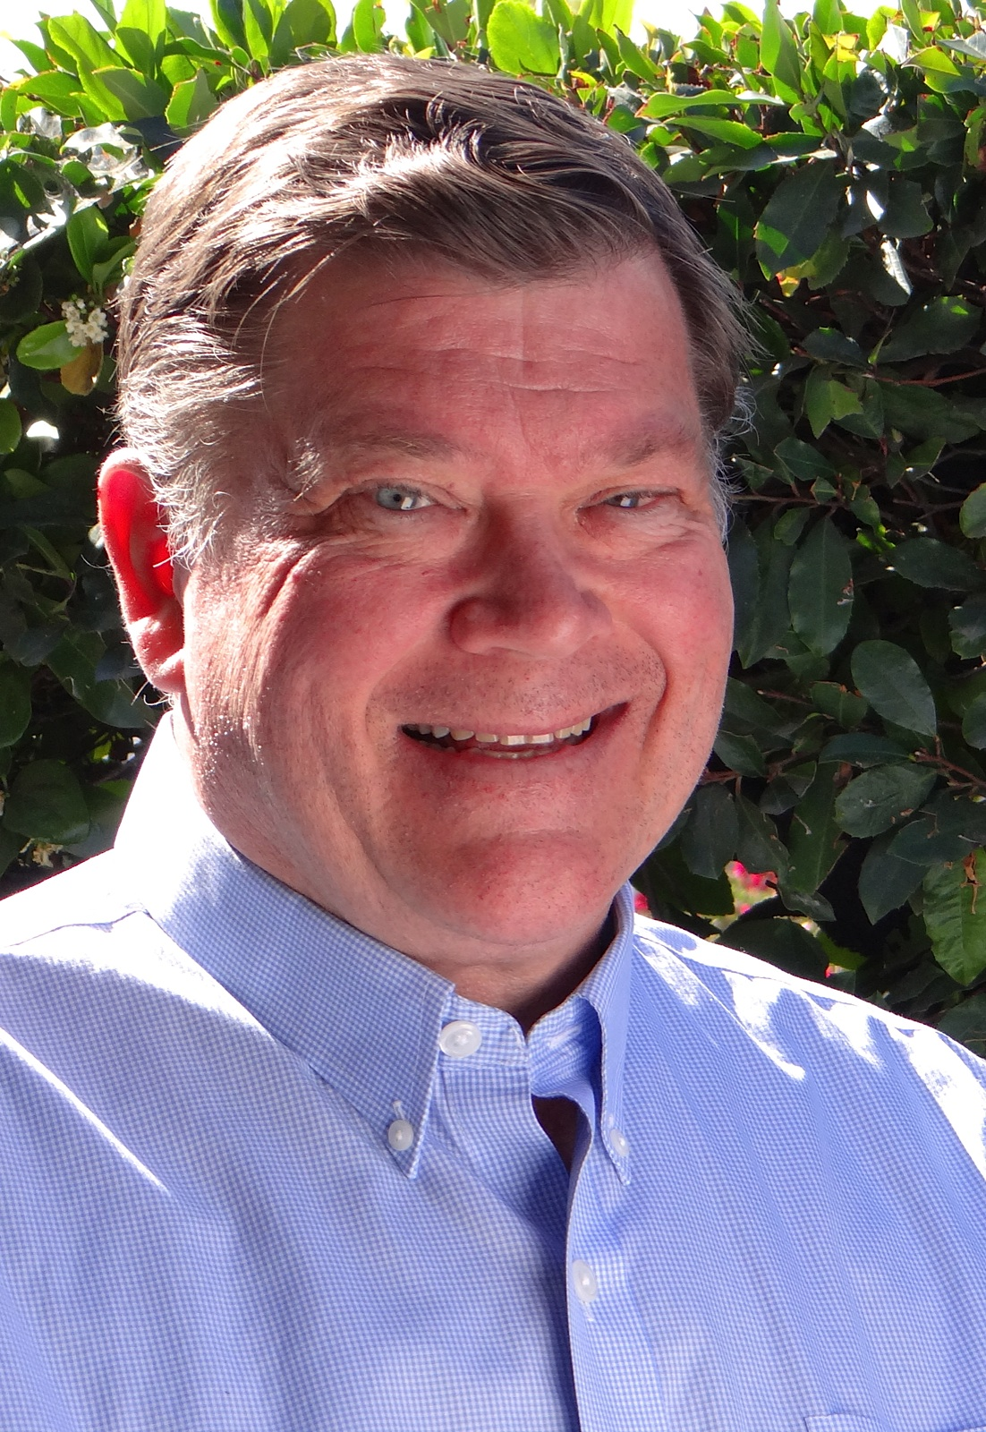  About Your Instructor: Paul Harvey recipient of prestigious national “Clinical Reflexology Award” from, RAA has helped many suffering from PTSD while working at the world famous Whitaker Wellness Institute. Paul has repeatedly taught PTSD with Reflexology to those working with veterans at Fort Lewis/McCord in Washington. Also benefitting hundreds of clinic patients suffering from Parkinson’s, MS, Arthritis and other debilitating conditions that affect balance using his unique PNF techniques. An Academy (AAR) Graduate, Paul is Past Chairperson of the National Health Federation (NHF), and Past Board member of the Reflexology Association of California (RAC), | Proprioceptive Neuromuscular Facilitation  Sunday, June 10  - Who may be helped using PNF techniques  - Explore the many benefits of PNF  - Takes techniques in CS workshops much deeper  - Learn the fine points and benefits of PNF, or as an in depth refresher for Condition Specific graduates

9AM - 5PM Up to 14 CE Hours, 7 each day

Location: 13315 W. Washington Blvd, LA, CA 90066 3rd Floor, TOT Room, near Lincoln Blvd, close to Marina del Rey, Free ground floor parking. Student lounge. Restaurants nearby. Ask for Hotel list.
Fee: PTSD $160 One month early, $170 thereafter. Prerequisite – Beginning Foot Reflexology
PNF $160 One month early, $170 thereafter. Prerequisite – Beginning Foot Reflexology
PTSD & PNF $310 One month early, $330 thereafter. Prerequisite – Beginning Foot Reflexology

Refund 100% if cancellation by day prior to class. Thereafter, refund less $25.
Receive: Certificate of Attendance CE Hours for ARCB, ABMP, NCBTMB & Many States

Administrative Address for correspondence & phone calls

American Academy of Reflexology, Bill Flocco, Director, 12719 Sarah Street, Studio City, CA 91604
Off 818 841-7741, eMail: AAReflex@aol.com www.AmericanAcademyofReflexology.com

---------------------------------------------------------------------------------------------------------------

Scan Mail or Call Your Registration Today PTSD 6/9/2018 and/or PNF 6/10/2018

PTSD June 9, 2018: Please reserve ________ places. Check or money order for $ ________________
PNF June 10, 2018: Please reserve ________ places. Check or money order for $ ________________
PTSD & PNF June 9 & 10, 2018: Please reserve ________ places. Check or money order for $ ________________

Please mail this form with check or money order payable to: American Academy of Reflexology

___ Visa ___ MasterCard Number ________ ________ ________ ________ Expiration Date ______ /______/________
Name ________________________________________________________________________________________________
Address _______________________________________________________________________________________________
City ___________________________________________________________ State ________ Zip _______________________
Phone (Home) (________) __________________ (Work) (________) ________________ (Cell) (_________) ______________
eMail Address __________________________________________________________________________________________

