**Foot Hand Ear Reflexology**

**Two Power Packed Workshops with Bill Flocco**

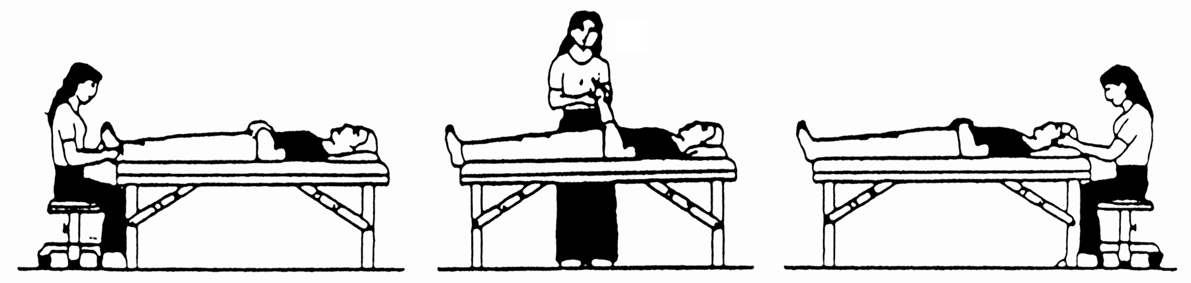

|  |  |
| --- | --- |
| **Pain Control & Stress Reduction**  **With Foot Hand Ear Reflexology * 3 CE Hours**  **For Beginners & Professional**  **\* 3 CE Hours: ARCB, NCBTMB, ABMP, many States**  During this powerful Hands-on Workshop, discover how to achieve ***profound stress reduction*** as well as pain relief, using gentle finger and thumb pressure on ears, hands and feet for relief of the following common health challenges:   * Allergies, Headaches, Sinusitis, Jaw, Neck * Heartburn, Stomach (Acid Reflex) * Colon (Colitis) * Sleep Disorders * Poor Nutrient Absorption, and more.   **\*\*\* Please Note:** **This is mostly a different body of knowledge from Saturday–Sunday. A powerful addition to the weekend!**  **When: Friday Evening, Oct 5, 2018**  **Where:** Country Inn & Suites by Carlson  3316 13th Avenue South, Fargo, ND 58103  For hotel reservations mention NDRA special rate  Hotel Telephone # 701 234-0565  **Time:** 6:00 PM - 9:00 PM  **Fee:** NDRA Members $40 by Sep 5th, $55 thereafter  Non-Members $60 by Sep 5th, $75 thereafter | **Integrated Foot Hand Ear Reflexology**  **For Musculoskeletal Issues & Pain *14 CE Hours**  **Prerequisite:** Foot Reflexology from a hands-on school  **\* 14 CE Hours ARCB, NCBTMB, ABMP, many States**  During this hands-on workshop you will learn how to do a reflex Feet Hands Ears for ***musculoskeletal issues*** from the head to the feet, and everything in between. Learn ***Priority Reflexing***, which one is best for relieving pain – feet, hands or ears – for each of ***twenty-nine (29) parts of the body***. Also discover ***Progression Reflexing*** – when reflexing all three – feet, hands, and ears – what is the best progress when reflexing for maximum results. Reflexologist and other professionals will be able to incorporate what is learned into their Reflexology and other practices for far greater results and increased income.  This is very much a Hands-On Workshop.  **Get far better results by Integrating Foot Hand Ear Reflexology during the same session!**  **When: Saturday-Sunday, Oct 6-7, 2018**  **Where:** Country Inn & Suites by Carlson  3316 13th Avenue South, Fargo, ND 58103  For hotel reservations mention NDRA special rate  Hotel Telephone # 701 234-0565  **Time:** 8:30 AM - 5:00 PM  **Fee:** NDRA Members $275 by Sep 5th, $300 thereafter  Non-Members $375 by Sep 5th, $400 thereafter  **Bring:** Therapy table, 1 sheet, 2 towels, pillow (if you need it for your own lower back), washable coloring pens, nail file |

**For Questions Contact:** Jan Benson at 701-361-9644, [jcbenson@cableone.net](mailto:jcbenson@cableone.net)

**------------------------------------------Please detach and return with your registration fee -------------------------------------------------**

**To Register** Enclose **🞏**Check (Please make check payable to **Bill Flocco)** & send to

**Tanya Boehland Reflexology, 1326 25th Street, Fargo, ND 58103**

___ Visa ___ MasterCard Number ________ ________ ________ ________ Expiration Date ______ /______/________

Name _______________________________________________________________________________________________________________

Address _____________________________________________________________________________________________________________

City _______________________________________________________________ State ________ Zip __________________-_______________

Phone (Home) (____________) _______________-____________________ (Cell) (____________) _______________-____________________

E-Mail Address ________________________________________________________________________________________________________