Metamorphosis
Metamorphosis is a gentle type of Reflexology done on the feet, hands, and head addressing core imprints and patterns that developed prenatally and are held in the body’s cellular memory.

- Profound relaxation as you learn to give and receive.  - Transformation in areas where you have been stuck / limited.  - Renewed energy balance and vitality in body, mind, spirit.  - The philosophy and back-ground of Metamorphosis.  - Some of the main core patterns that are formed prenatally and the effect they have on the rest of our lives.  - How to give a Metamorphosis session to yourself, your family, and others.  - How the empowering focus of this modality can enhance your practice and assist you in achieving your goals. | 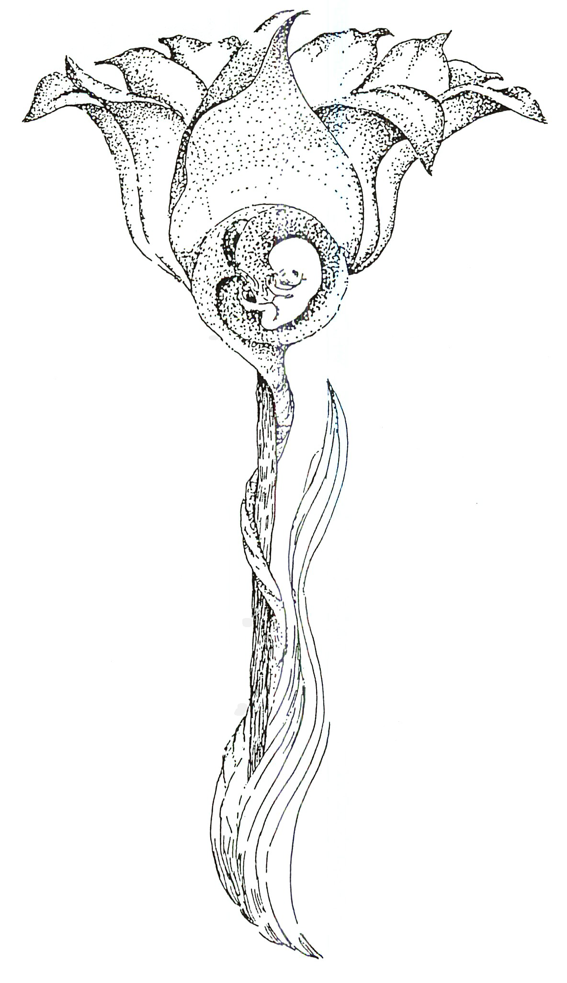 | 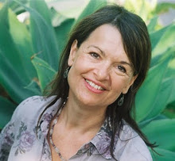  Maryejo del Meijer has practiced and taught Metamorphosis for over 25 years and has a bodywork practice in Santa Barbara. With 2 Masters Degrees in Counseling & Psychology she’s sensitive to creating a safe learning environment where transformation can occur.

Advanced Metamorphosis
April 14, 2018 Sat 10 AM – 5 PM 6 CE Hours

Location: 13315 W. Washington Blvd, LA, CA 90066 3rd Floor, TOT Room, near Lincoln Blvd, close to Marina del Rey, Free ground floor parking. Student lounge. Restaurants nearby. Ask for Hotel list.
Advanced $137 One month early, $150 thereafter. Prerequisite – Beginning Metamorphosis
Refund 100% if cancellation by day prior to class. Thereafter, refund less $25.
Receive: Certificate of Attendance CE Hours for ARCB, ABMP, NCBTMB & Many States

Administrative Address for correspondence & phone calls

American Academy of Reflexology, Bill Flocco, Director, 12719 Sarah Street, Studio City, CA 91604
Off 818 841-7741, eMail: AAReflex@aol.com www.AmericanAcademyofReflexology.com

------------------------------------------------------------------------------------------------------

Scan Mail or Call Your Registration Today Advanced Metamorphosis 4/14/2018

□ Advanced Metamorphosis April 14, 2018: Please reserve ________ places. Check or money order for $ ________________

Please mail this form with check or money order payable to: American Academy of Reflexology

___ Visa ___ MasterCard Number ________ ________ ________ ________ Expiration Date ______ /______/________
Name ________________________________________________________________________________________________
Address _______________________________________________________________________________________________
City ___________________________________________________________ State ________ Zip _______________________
Phone (Home) (________) __________________ (Work) (________) ________________ (Cell) (_________) ______________
eMail Address __________________________________________________________________________________________

