`

Beginning Foot Hand Ear Reflexology & Certificate Course

CE Hours: 14 CE Hours for ARCB, ABMP, NCBTMB & Many States

Hand Ear Reflexology Workshop Sep 29-30  9:00 AM - 5:30 PM Both Days  Help yourself, your family, friends, & clients to be pain free & have far better health. Learn a time proven one-hour Hand & one-hour Ear Reflexology Routine that can be used separately or combined with other modalities. Add this to the Foot Reflexology class the weekend before.  Working with all three is far more effective than just Foot Reflexology.  Instructor: Stefanie Sabounchian  Continue Your Reflexology Studies  After completing the Beginning Foot Hand Ear class, the more serious student can deepen their knowledge, skills, confidence & results,  by continuing with:  Beginning Integrated Foot Hand Ear Reflexology  Watch for this class to be offered during 2018 50 CE Hours  Advanced Integrated Foot Hand Ear Reflexology  Watch for this class to be offered during 2018 50 CE Hours  Instructors: Lisa Chan, Bill Flocco, Stefanie Sabounchian | 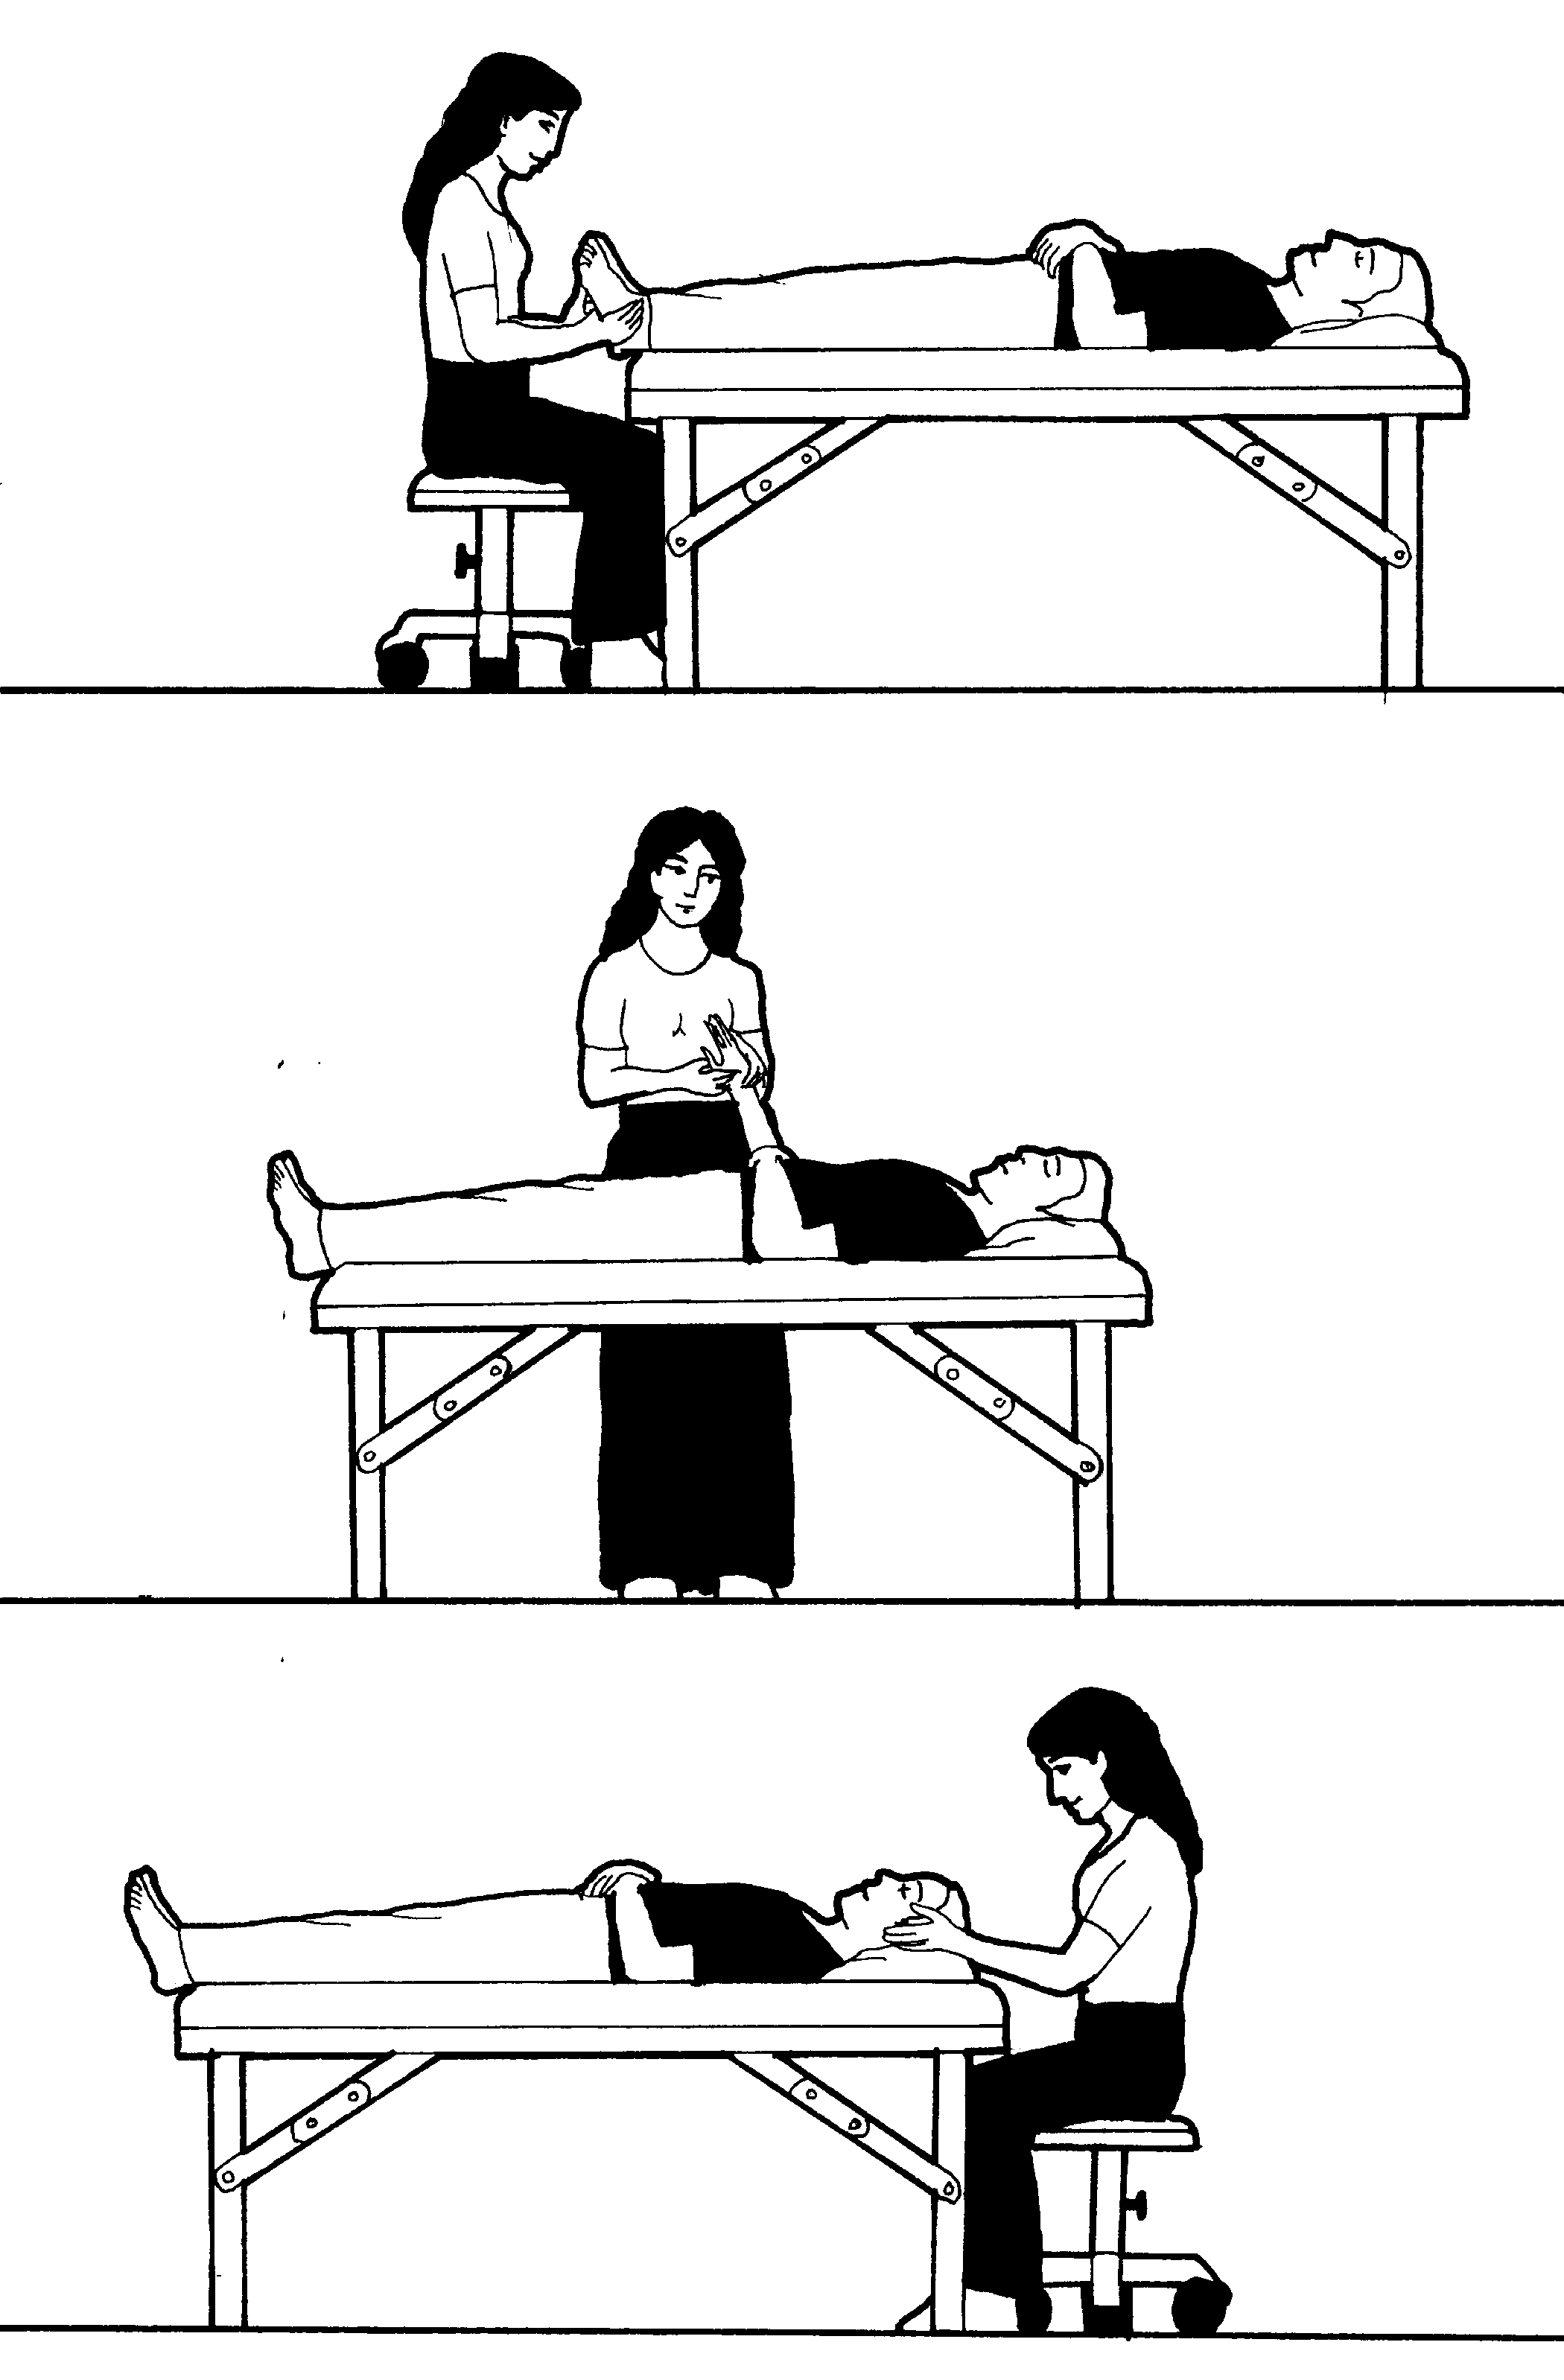

School Campus for Classes: The American Academy of Reflexology conducts it’s classes at
13315 W. Washington Blvd, LA, CA 90066 3rd Floor, TOT Room.
Close to Marina del Rey, Venice Beach, Santa Monica, & 12 minutes from Los Angeles Airport LAX.
Parking: ground floor. Restaurants near by. Motel list available upon request.

Refund Policy: 100% refund if cancellation received by day prior to the start of class. Thereafter, refund will be made less a $25 fee, Or registration may be applied to future class or transferred to another person by the applicant.

Administrative Address for Correspondence & Phone Calls

American Academy of Reflexology, Bill Flocco, Director, 12719 Sarah Street, Studio City, CA 91604
818 841-7741 AAReflex@aol.com www.AmericanAcademyofReflexology.com
Class size is limited. We look forward to meeting you and sharing this adventure with you.

Scan Mail or Call Your Registration Today Hand & Ear Sep 29-30, 2018
You can also Register online: www.AmericanAcademyofReflexology.com

If paying by check, please print your name ________________________________________________________
Please make checks payable to American Academy of Reflexology

Address __________________________________ City ____________________ State _______ Zip _________
Phone (Home) (_____) ______________ (Work) (_____)________________ (Cell) (______)________________
eMail Address _______________________________________________________________________________

Credit Card Visa MasterCard
Credit Card # ___________________________________________________ Expiration date _______________
Name On Card (Please print) ___________________________________________________________________

If payment received 4 weeks Late registrations
prior to start of seminar or at the door
Hand & Ear Reflexology $210 $235

