Face Reflexology

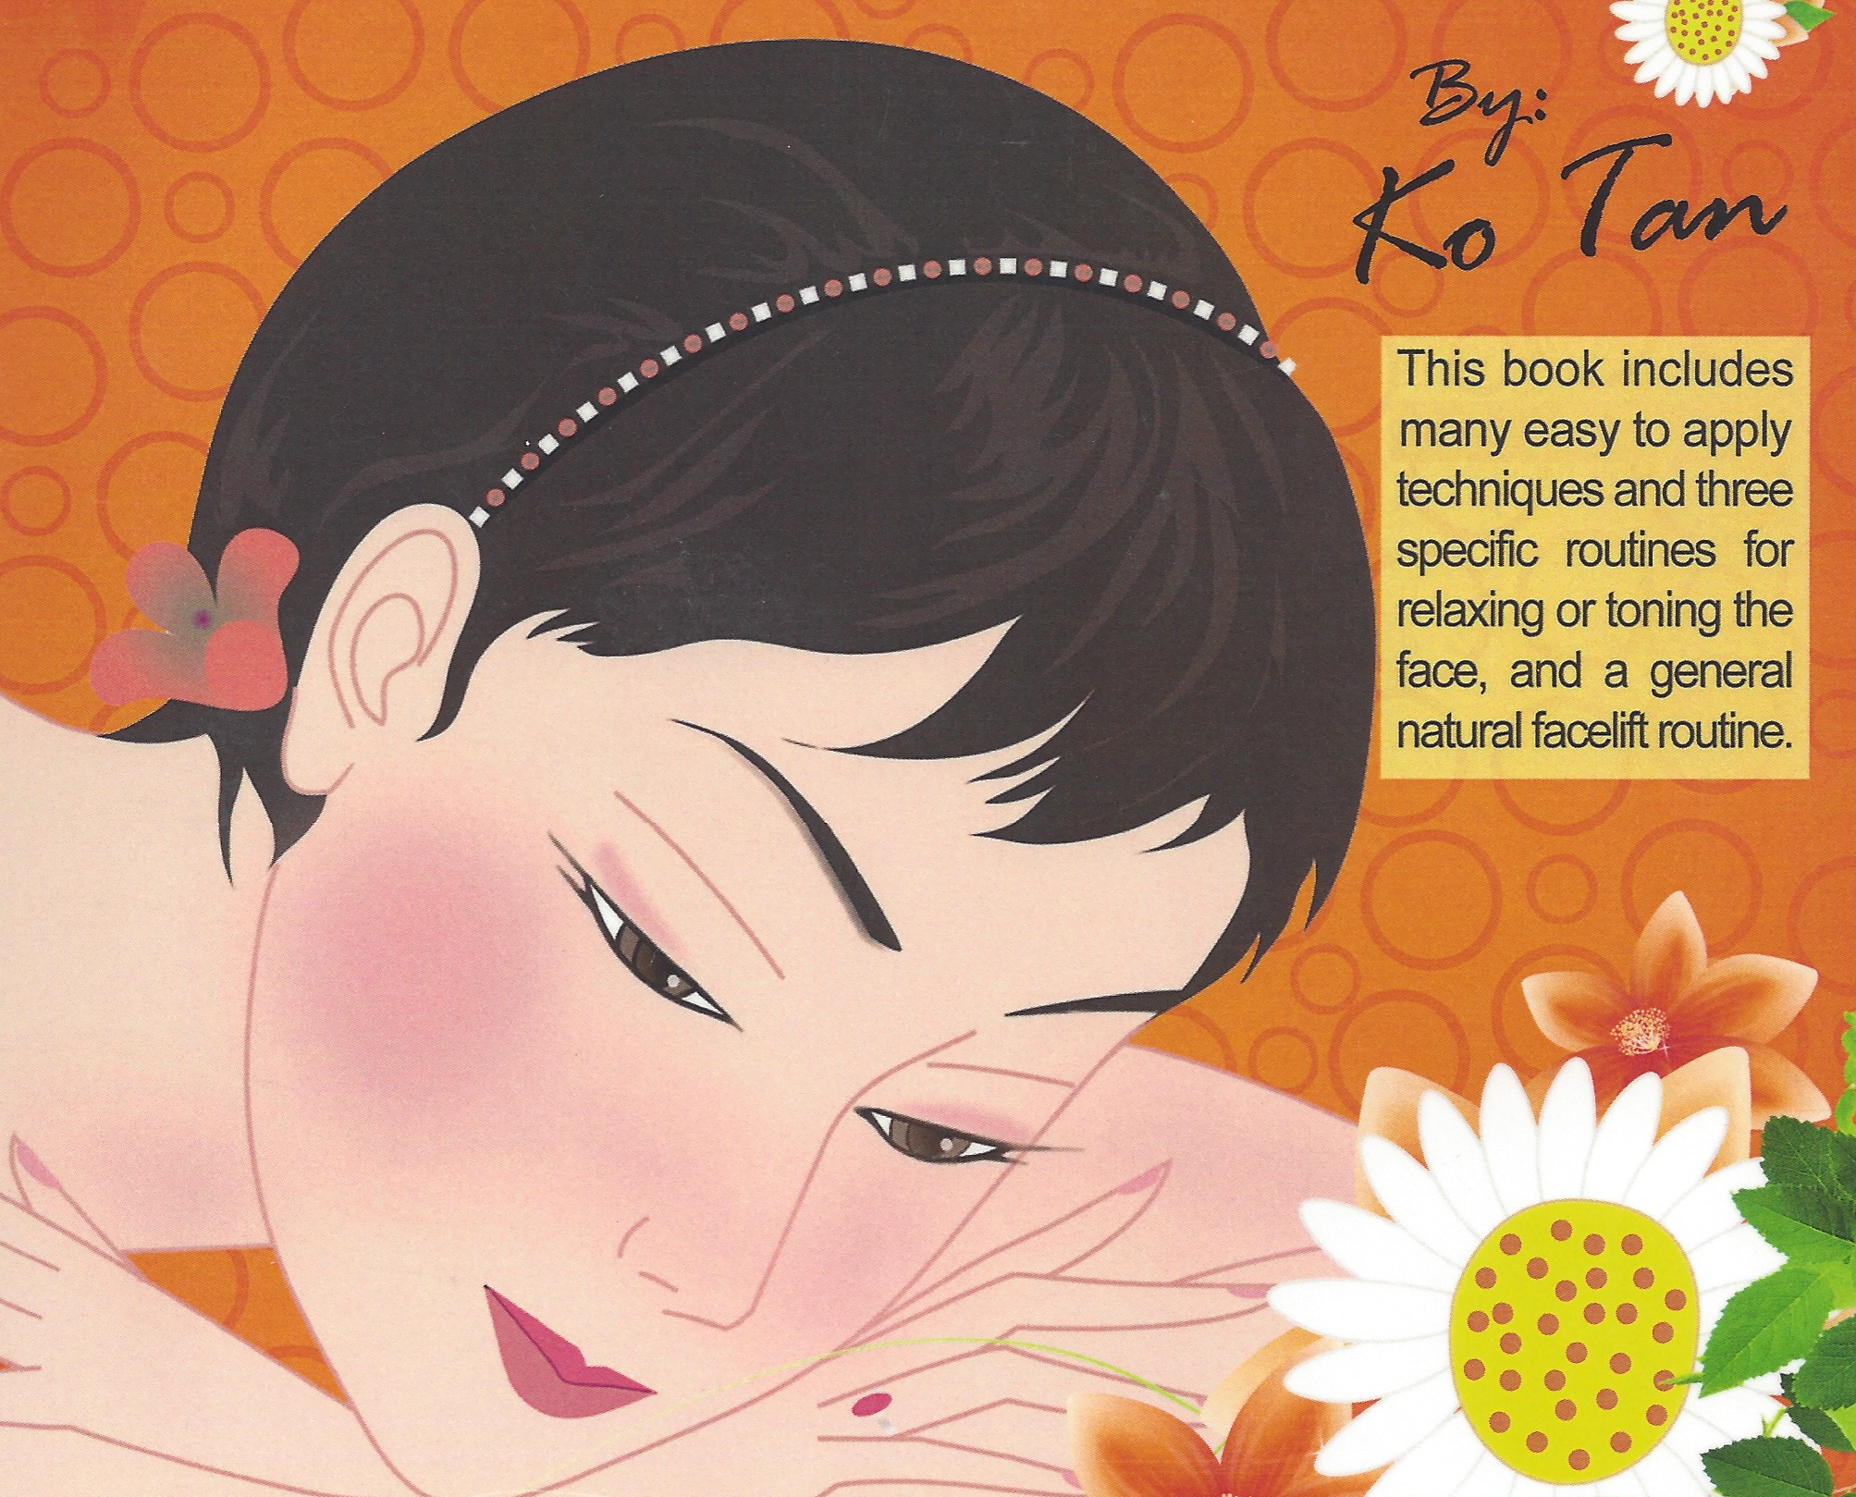 | Face Reflexology is a science and art of utilizing the mini maps of the human body found on the face to balance and rejuvenate the whole body. Face Reflexology uses a series of finger and thumb techniques via the mini maps on the face that resembles the human body to achieve balance to the body, mind and spirit. In this class you will be learning the 2 important mini reflexology maps of the body found on the face. Along with the specific techniques used on the face, you will also learn the 3 major face Reflexology routines giving you different options, and a lymphatic drainage routine on the face.
Based on class interest, your Instructor Ko Tan might also discuss the basic concepts of meridians, herbal formulas, essential oil remedies and Bach flower remedies utilizing About Face book by Ko Tan as tools to learn how to look and feel great. Tan is also author of Traditional Chinese Medicine Simplified and is known for his professional elegant teaching style. Tan’s book About Face will be available for sale during class.

February 3-4, 2018 Saturday & Sunday 9:00 AM – 5:00 PM Both Days

Location: 13315 W. Washington Blvd, LA, CA 90066 3rd Floor, TOT Room, near Lincoln Blvd, close to Marina del Rey, Free ground floor parking. Student lounge. Restaurants nearby. Ask for Hotel list.
Fee: $320 One month early, $340 thereafter. Refund 100% if cancellation by day prior to class. Thereafter, refund less $25. Or, fee may be applied to future class or transferred to another person. Class size limited.
Prerequisite: Beginning Foot Reflexology from a hands-on school.
Receive: Certificate of Attendance
Hours: 14 CE Hours for ARCB, ABMP, NCBTMB & Many States

Administrative Address for correspondence & phone calls

American Academy of Reflexology, Bill Flocco, Director, 12719 Sarah Street, Studio City, CA 91604
818 841-7741 AAReflex@aol.com www.AmericanAcademyofReflexology.com

Scan, Mail or Call Your Registration Today Face Reflexology Feb 3-4, 2018
You can also Register online: www.AmericanAcademyofReflexology.com

Please reserve ________ places for me. My check or money order for $ ________________ is enclosed

Please mail this form with check or money order payable to: American Academy of Reflexology

___ Visa ___ MasterCard Number ________ ________ ________ ________ Expiration Date ______ /______/________
Name ________________________________________________________________________________________________
Address _______________________________________________________________________________________________
City ___________________________________________________________ State ________ Zip _______________________
Phone (Home) (________) __________________ (Work) (________) ________________ (Cell) (_________) ______________
eMail Address __________________________________________________________________________________________

