Foot Hand Ear Reflexology
Two Power Packed Workshops with Bill Flocco

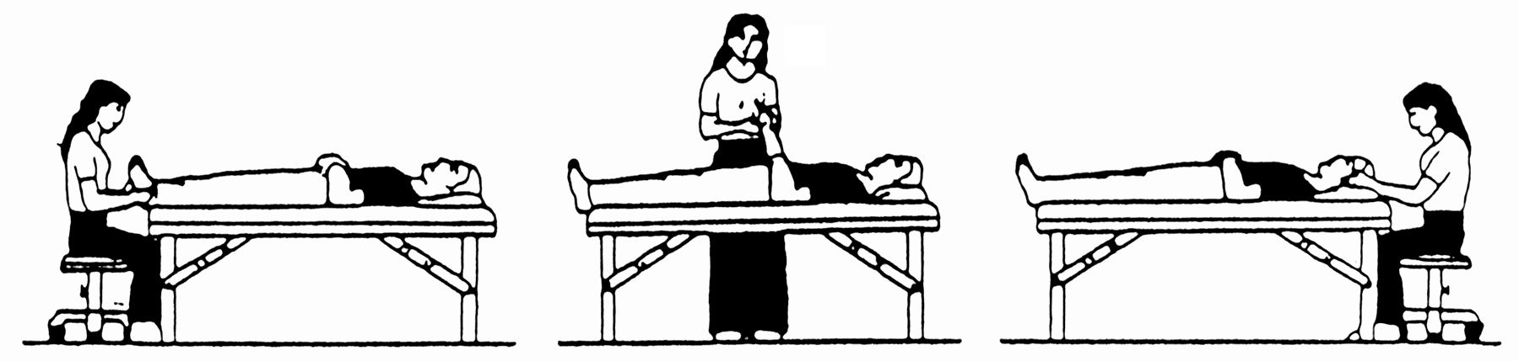

Pain Control & Stress Reduction  With Foot Hand Ear Reflexology * 3 CE Hours  For Beginners & Professional  * 3 CE Hours: ARCB, NCBTMB, ABMP, many States  During this powerful Hands-on Workshop, discover how to achieve profound stress reduction as well as pain relief, using gentle finger and thumb pressure on ears, hands and feet for relief of the following common health challenges:  - Allergies, Headaches, Sinusitis, Jaw, Neck  - Heartburn, Stomach (Acid Reflex)  - Colon (Colitis)  - Sleep Disorders  - Poor Nutrient Absorption, and more.  *** Please Note: This is mostly a different body of knowledge from Saturday–Sunday. A powerful addition to the weekend!  When: Friday Evening, Date, Sep 29, 2017  Where: Pine Point Conference Room  675 Main Street Howard Johnsons Hotel–South Portland, ME  Time: 6:00 PM - 9:00 PM  Fee: MCR Members $40 by Sep 1st, $55 thereafter  Non-Members $60 by Sep 1st, $75 thereafter  Full refund if notified by Sep 1st, 2017 | Integrated Foot Hand Ear Reflexology  For Musculoskeletal Issues & Pain *14 CE Hours  Prerequisite: Foot Reflexology from a hands-on school  * 14 CE Hours ARCB, NCBTMB, ABMP, many States  During this hands-on workshop you will learn how to do a reflex Feet Hands Ears for musculoskeletal issues from the head to the feet, and everything in between. Learn Priority Reflexing, which one is best for relieving pain – feet, hands or ears – for each of twenty-nine (29) parts of the body. Also discover Progression Reflexing – when reflexing all three – feet, hands, and ears – what is the best progress when reflexing for maximum results. Reflexologist and other professionals will be able to incorporate what is learned into their Reflexology and other practices for far greater results and increased income.  This is very much a Hands-On Workshop.  Get far better results by Integrating Foot Hand Ear Reflexology during the same session!  When: Saturday-Sunday, Sep 30-Oct 1, 2017  Where: Pine Point Conference Room  675 Main Street Howard Johnsons Hotel–South Portland, ME  Time: 8:30 AM - 5:00 PM  Fee: MCR Members $275 by Sep 1st, $300 thereafter  Non-Members $375 by Sep 1st, $400 thereafter  Full refund if notified by Sep 1, 2017  Bring: Therapy table, 1 sheet, 2 towels, pillow (if you need it for your own lower back), washable coloring pens, nail file

FOR MORE INFORMATION Contact: Nancy Butler-Smith 207-592-4573 Email: info@mcronline.org

A detailed Information Packet will be sent which outlines Location Map, Travel Directions and Lodging
--------------------------------Please detach and return with your registration fee -------------------------------

Enclosed is $_____ Check Please make check payable to MCR-Maine Council of Reflexologists
Send to: P. O. Box 5583, Augusta, Maine 04332

Name _______________________________________________________________________________________________________________
Address _____________________________________________________________________________________________________________
City _______________________________________________________________ State ________ Zip __________________-_______________
Phone (Home) (____________) _______________-____________________ (Cell) (____________) _______________-____________________
E-Mail Address ________________________________________________________________________________________________________

