Neuroendocrine
Foot HandEar Reflexology

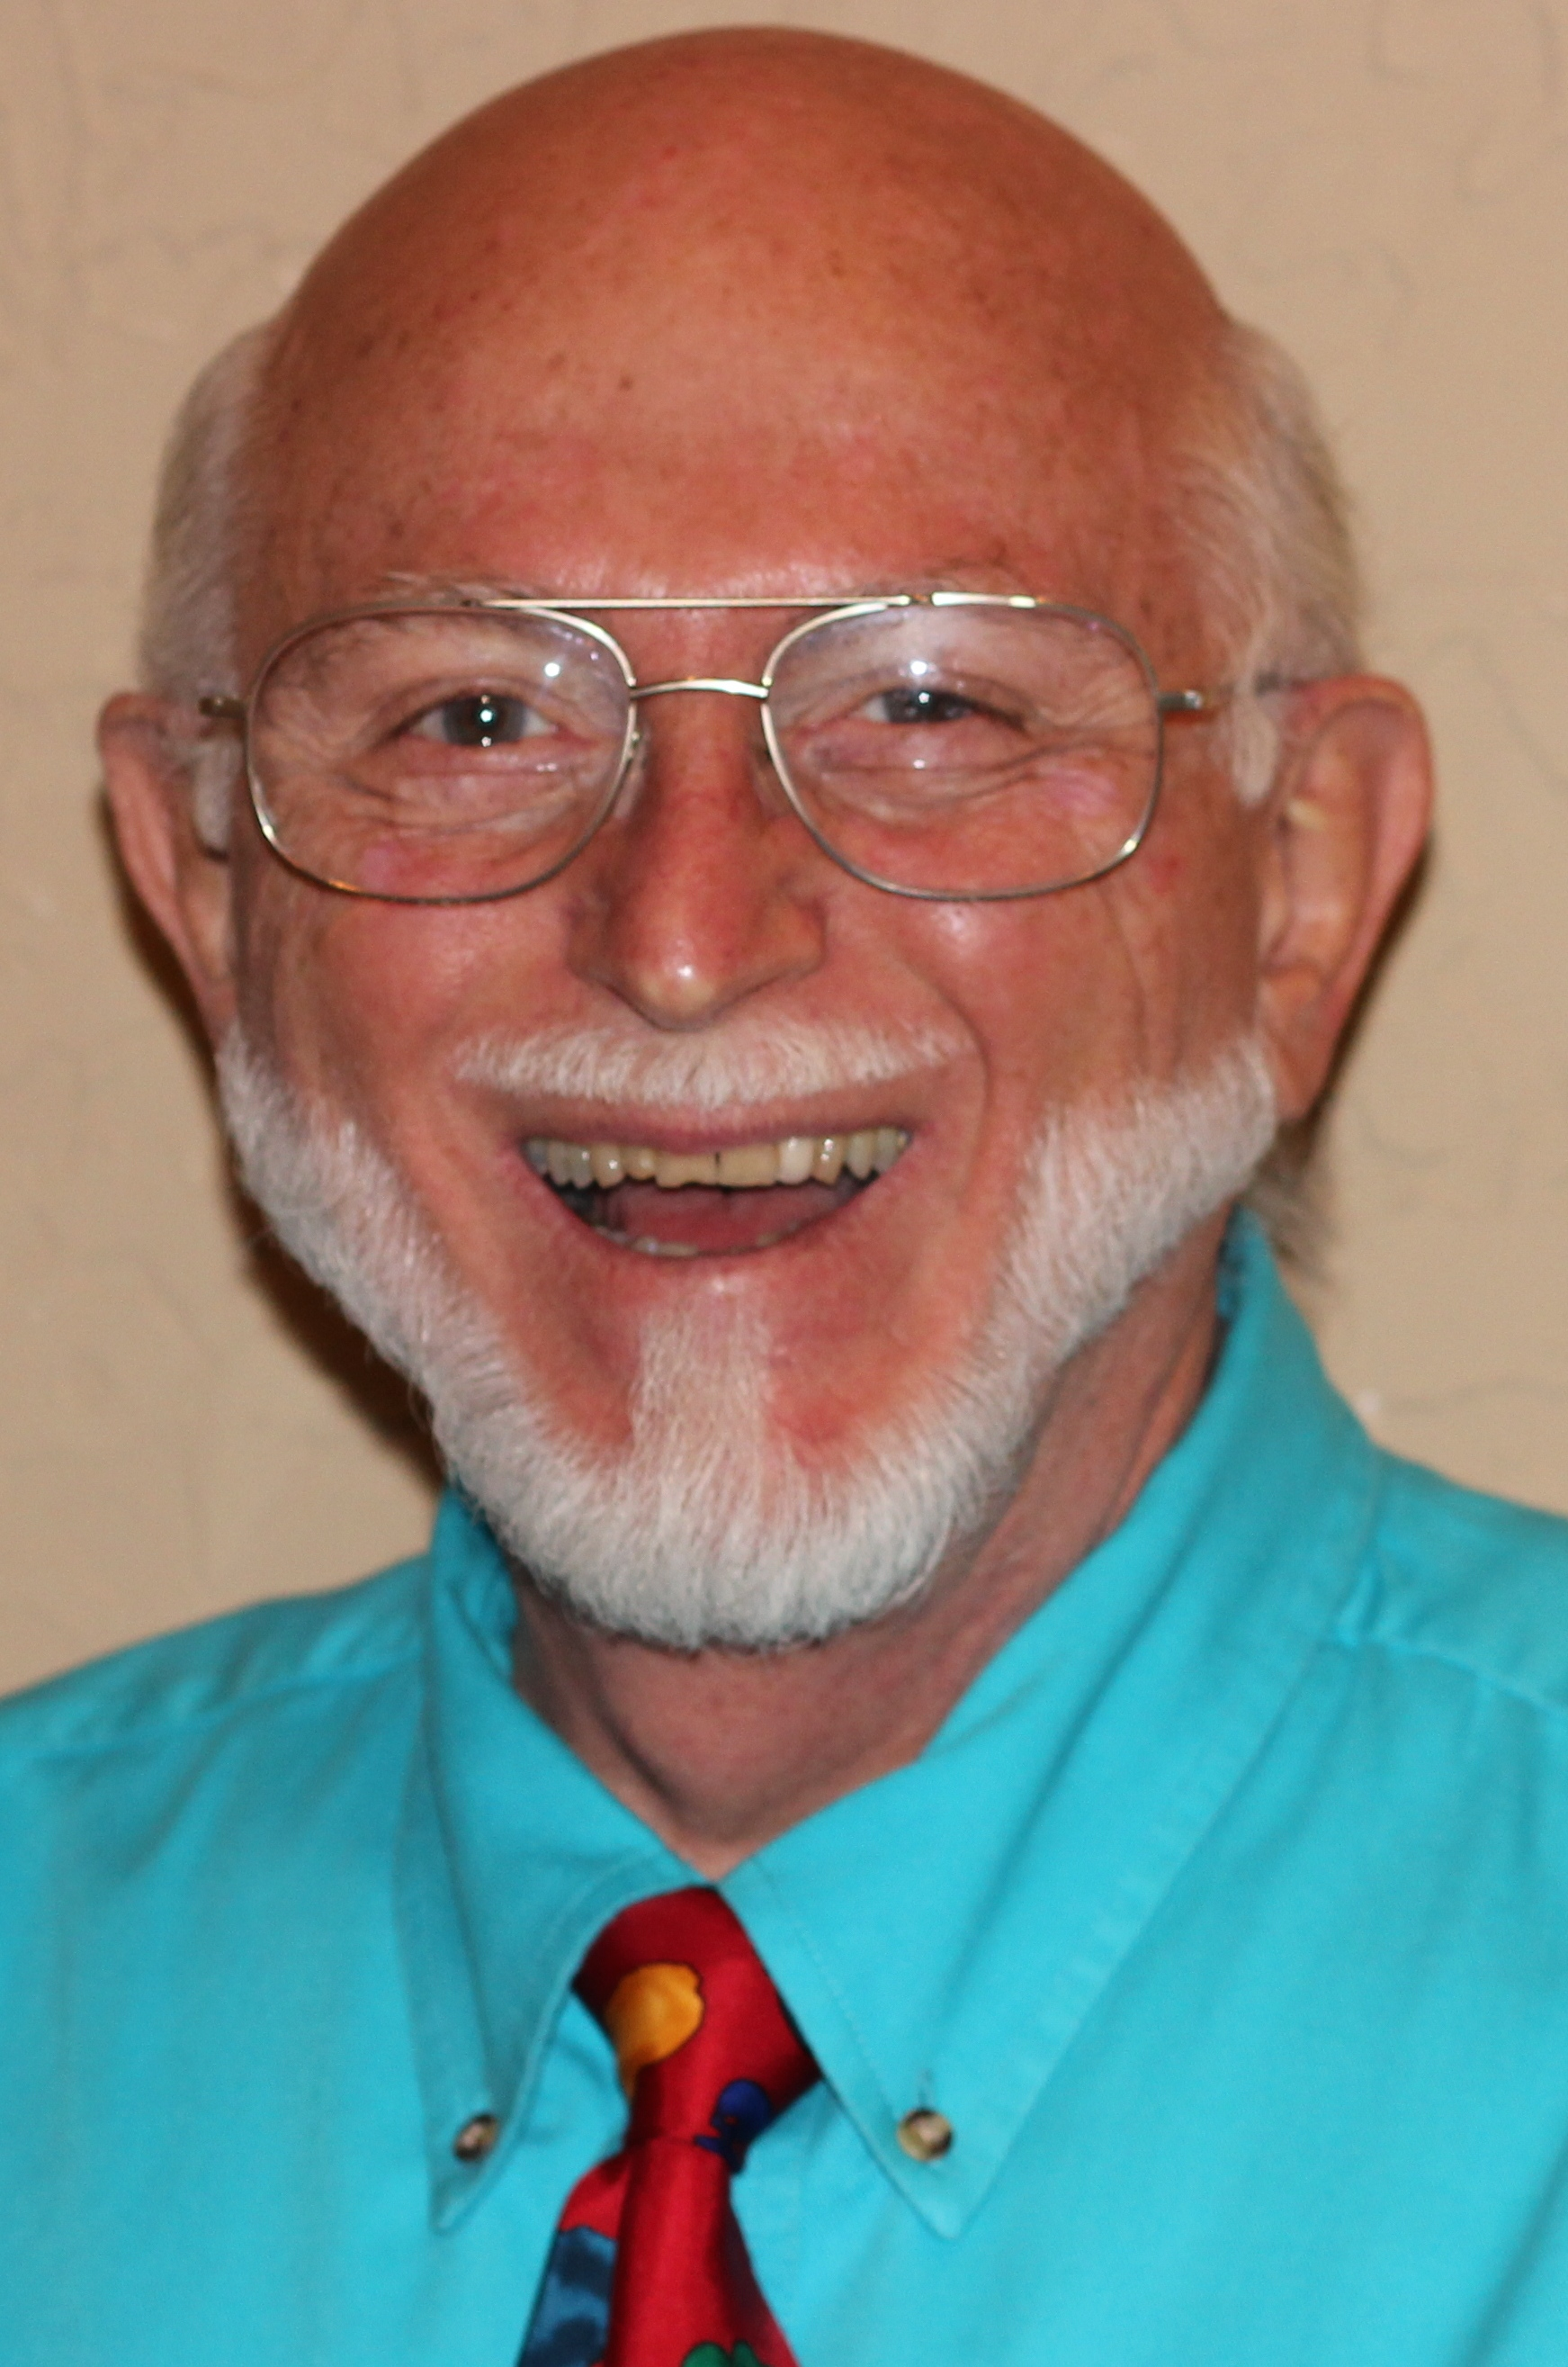 | Do you and your clients want better hormonal balance? Energy? Sex? Metabolism? Sleep? Bone strength? Do you know whichanatomical systems control the overwhelming number of functions and health of the body? Go deeper into how Reflexology helps support many of the body's neurologic and hormonal functions. During this mostly hands-on workshop, practitioners will learn where and how to reflex feet, and for much better results, hands and ears, for all of these parts of the body: pineal, hypothalamus, pituitary, thyroid, parathyroid, thymus, pancreas, ovaries, testes and six other locations in the body where vital hormones are produced. Additionally we will reflex for the brain, spinal cord, couda equine, 12 cranial nerves, vagus nerve, spinal nerves, cervical, celiac, superior & inferior mesenteric ganglia, sympathetic &para sympathetic nervous systems. We will also explore the vital function of each of these parts of the body, common types of stressors, along with related malfunctions and pathologies that might show up in our clients. This class is ideal for the beginning and veteran Reflexologist, for Massage Therapists, Bodyworkers, as well as for all natural health care practitioners. Prerequisite: Beginning Foot Reflexology or it’s equivalent from a hands-on school. Instructor, Bill Flocco

May 13-14, 2017 Saturday & Sunday 9:00 AM – 5:30 PM Both Days

Location:13315 W. Washington Blvd, LA, CA 90066 3rd Floor, TOT Room, near Lincoln Blvd, close to Marina del Rey, Free ground floor parking. Student lounge. Restaurants nearby. Ask for Hotel list.
Fee:$275 One month early, $325 thereafter. Refund100% if cancellation by day prior to class. Thereafter, refund less $25. Or, fee may be applied to future class or transferred to another person. Class size limited.
Prerequisite: Beginning Foot Reflexology or equivalent from a hands-on school
Receive: Document of attendance with class title, hours, school & teachers name, location.
CE Hours:14 CE HoursforARCB, ABMP, NCBTMB& Many States

Administrative Address for correspondence&phone calls

American Academy of Reflexology, Bill Flocco, Director, 12719 Sarah Street, Studio City, CA 91604
818 841-7741 AAReflex@aol.com www.AmericanAcademyofReflexology.com

Scan, Mail or Call Your Registration Today Neuroendocrine FHEMay 13-14, 2017
You can also Register online: www.AmericanAcademyofReflexology.com
f

Please reserve ________ places for me. My check or money order for $ ________________ in enclosed

Please mail this form with check or money order payable to:
American Academy of Reflexology 12719 Sarah Street, Studio City, CA 91604

___ Visa ___ MasterCard Number ________ ________ ________ ________ Expiration Date ______ /______/________
Name ________________________________________________________________________________________________
Address _______________________________________________________________________________________________
City ___________________________________________________________ State ________ Zip _______________________
Phone (Home) (________) __________________ (Work) (________) ________________ (Cell) (_________) ______________
eMail Address __________________________________________________________________________________________

