Polarity
Foot & Hand Reflexology

Polarity Reflexology combines working energetically with the Five Elements of Polarity Therapy; Earth, Fire, Water, Air and Ether, with Foot & Hand Reflexology. Learn how the 5 elements (slightly different from Chinese Medicine) affect you, your client and your sessions together. It can become part of the way you communicate in all aspects of your life, including how you, the practitioner speak, move, touch and make protocol-related decisions, i.e. what areas of the feet and hands to emphasize for balancing your client elementally. A completely new In-Take Form and protocols are included, based on your client's Five Element needs, such as grounding/fear (earth), motivating creativity (fire), grieving (ether), panic (air), not letting go (water). Being able to identify these elements in your clients, their bodies, their voices and their complaints helps identify opportunities for incorporating the 5 elements seamlessly into your sessions. Instructor, Lisa Chan, LAc, PhD, and RPP (Registered Polarity Practitioner) considers the principles of Polarity Reflexology a core part of all of her sessions as well as the larger world around her, outside of sessions. Come join the exploration of the 5 Elements, their corresponding sounds, music, voice, touch, movement, body mapping and Foot & Hand Reflexology in a new way of seeing your world and making a deeper, more connected impact on your work and life. This class is open to the enthusiastic non-reflexologist, massage therapists, Bodyworkers, Reflexologists, others in the caring arts, but some knowledge of reflexology is helpful. | 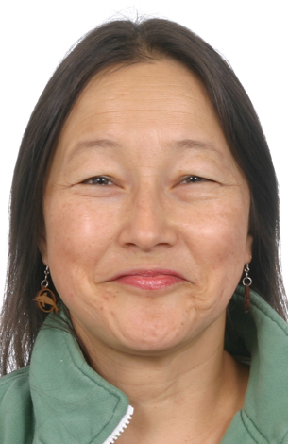

May 28-29, 2016 Saturday & Sunday 10:00 AM – 5:00 PM Both Days

Location: 13315 W. Washington Blvd, LA, CA 90066 3rd Floor, TOT Room, near Lincoln Blvd, close to Marina del Rey, Free ground floor parking. Student lounge. Restaurants nearby. Ask for Hotel list.
Fee: $250 One month early, $275 thereafter. Refund 100% if cancellation by day prior to class. Thereafter, refund less $25. Or, fee may be applied to future class or transferred to another person. Class size limited.
Open to Beginners & Professionals
Receive: Document of attendance with class title, hours, school & teachers name, location.
CE Hours: 12 CE Hours for ARCB, ABMP, NCBTMB & Many States

Administrative Address for correspondence & phone calls

American Academy of Reflexology, Bill Flocco, Director, 12719 Sarah Street, Studio City, CA 91604
818 841-7741 AAReflex@aol.com www.AmericanAcademyofReflexology.com

Scan, Mail or Call Your Registration Today Polarity FH Reflexology May 28-29, 2016
You can also Register online: www.AmericanAcademyofReflexology.com
f

Please reserve ________ places for me. My check or money order for $ ________________ in enclosed

Please mail this form with check or money order payable to: American Academy of Reflexology

___ Visa ___ MasterCard Number ________ ________ ________ ________ Expiration Date ______ /______/________
Name ________________________________________________________________________________________________
Address _______________________________________________________________________________________________
City ___________________________________________________________ State ________ Zip _______________________
Phone (Home) (________) __________________ (Work) (________) ________________ (Cell) (_________) ______________
eMail Address __________________________________________________________________________________________

