Pathologies
Of The Feet Hands Outer Ears

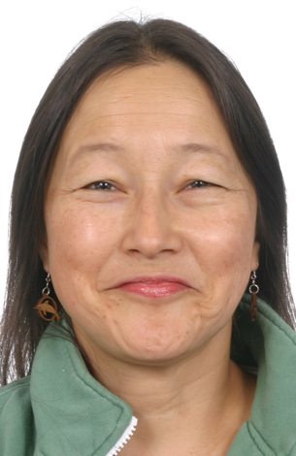 | While in Western Pathology Classes in Acupuncture Collage, I constantly found myself exclaiming, 'Reflexologists need to know this!' "Who knew that acupuncture school could send me back to Reflexology with more dedication than ever? I understand that Reflexologists and other natural health practitioners do not diagnose, but knowledge is power." - Lisa M. Chan, LAc, PhD. It seems, more than ever, Reflexologists are working closely with their Western and Eastern medicine counterparts. With so many of the symptoms of disease appearing on the feet and hands, Bill Flocco has agreed to hold this pathology class. (Pathology = the study of disease) Anyone dealing with feet, hands and outer ears would benefit from knowing or reviewing some of the possible reasons that people have non-healing wounds, edema, swelling, shooting pains, structural irregularities, weakness, neuropathy, plantar fasciitis, carpal tunnel and repetitive disorders; or how diabetes, genetic disorders, DVT, MRSA, TB, AIDS, allergic reactions, cellulitis, phlebitis, lymphedema, syphilis, possible skin cancer, athletes foot, and how these may show up in, or impact feet, hands or outer ears. And, although Reflexologists and natural health practitioners do not diagnose, it can be valuable to learn when, and some ways of how, to refer clients to podiatrists, chiropractors, ERs, MDs and dermatologists.
Additionally, learn hands-on techniques and exercises to help with structural issues of the feet and hands, as well as when to glove up and mask up with your clients, and how to clear your session/treatment rooms and yourselves after working with sick or possibly contagious people.

August 13-14, 2016 Saturday & Sunday 10:00 AM – 5:00 PM Both Days

Location: 13315 W. Washington Blvd, LA, CA 90066 3rd Floor, TOT Room, near Lincoln Blvd, close to Marina del Rey, Free ground floor parking. Student lounge. Restaurants nearby. Ask for Hotel list.
Fee: $250 One month early, $275 thereafter. Refund 100% if cancellation by day prior to class. Thereafter, refund less $25. Or, fee may be applied to future class or transferred to another person. Class size limited.
Open to Beginners & Professionals
Receive: Document of attendance with class title, hours, school & teachers name, location.
CE Hours: 12 CE Hours for ARCB, ABMP, NCBTMB & Many States

Administrative Address for correspondence & phone calls

American Academy of Reflexology, Bill Flocco, Director, 12719 Sarah Street, Studio City, CA 91604
818 841-7741 AAReflex@aol.com www.AmericanAcademyofReflexology.com

Scan, Mail or Call Your Registration Today Pathologies FHE August 13-14, 2016
You can also Register online: www.AmericanAcademyofReflexology.com
f

Please reserve ________ places for me. My check or money order for $ ________________ in enclosed

Please mail this form with check or money order payable to: American Academy of Reflexology

___ Visa ___ MasterCard Number ________ ________ ________ ________ Expiration Date ______ /______/________
Name ________________________________________________________________________________________________
Address _______________________________________________________________________________________________
City ___________________________________________________________ State ________ Zip _______________________
Phone (Home) (________) __________________ (Work) (________) ________________ (Cell) (_________) ______________
eMail Address __________________________________________________________________________________________

