`

Beginning Foot Hand Ear Reflexology & Certificate Course

CE Hours: 28 CE Hours for ARCB, ABMP, NCBTMB & Many States

Foot Reflexology Class Sep 10-11  Hand & Ear Reflexology Class Sep 24-25  9:00 AM - 5:30 PM Both Days  Help yourself, your family, friends, & clients to be pain free & have far better health. Learn effective Foot, Hand, & Ear Reflexology Routines to use separately or combine with other modalities. Working with all three is far more effective than just Foot Reflexology. Instructor, Stefanie Sabounchian.  Continue Your Reflexology Studies  The more serious student can deepen their knowledge, skills,  confidence & results, after the Foot Hand Ear Class, by continuing with:  Beginning Integrated Foot Hand Ear Reflexology  October 21, 22, 23, November 11, 12, 13, 2016 50 CE Hours  Advanced Integrated Foot Hand Ear Reflexology  Watch for this advanced class to be offered during 2017 50 CE Hours  Instructors: Lisa Chan, Bill Flocco, Stefanie Sabounchian | 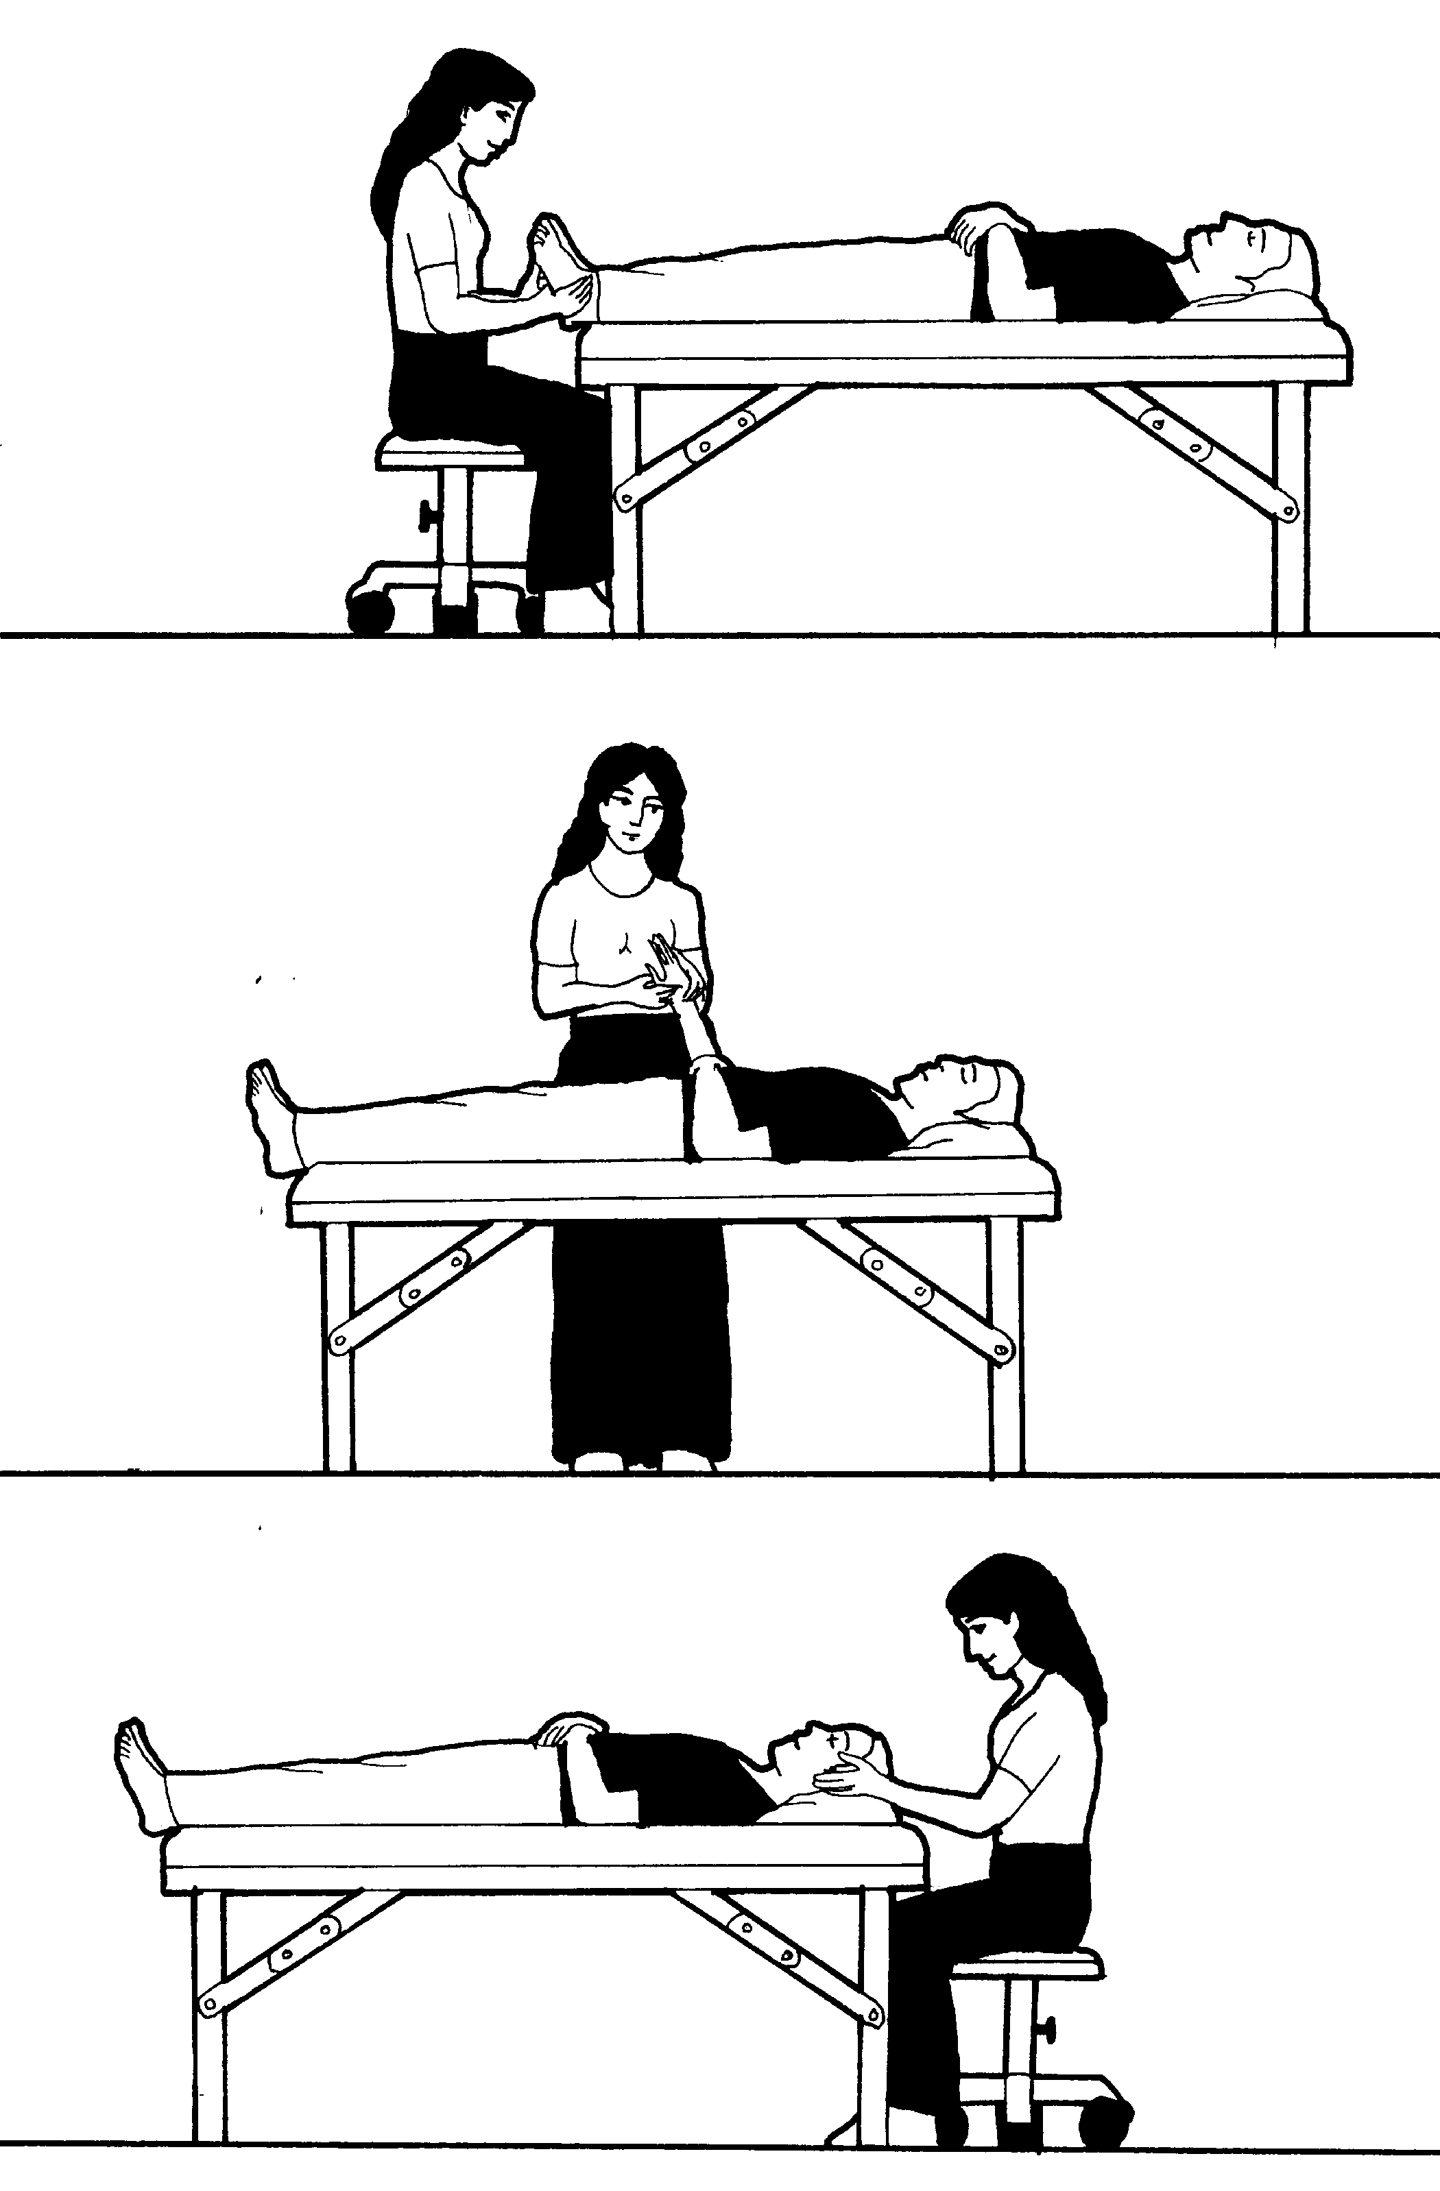

Please see School Catalog for important details, it’s on the Academy Education Web Site, or give us a call.
www.AmericanAcademyofReflexology.com

School Campus for Classes: The American Academy of Reflexology conducts it’s classes at
13315 W. Washington Blvd, LA, CA 90066 3nd Floor, TOT Room, close to Marina del Rey, Santa Monica, & LAX.
Parking: ground floor. Restaurants near by. Motel list available upon request.

Refund Policy: 100% refund if cancellation received by day prior to the start of class. Thereafter, refund will be made less a $25 fee, Or registration may be applied to future class or transferred to another person by the applicant.

Administrative Address for Correspondence & Phone Calls

American Academy of Reflexology, Bill Flocco, Director, 12719 Sarah Street, Studio City, CA 91604
818 841-7741 AAReflex@aol.com www.AmericanAcademyofReflexology.com
Class size is limited. We look forward to meeting you and sharing this adventure with you.

Scan Mail or Call Your Registration Today FHE Sep 10-11, 24-25, 2016
You can also Register online: www.AmericanAcademyofReflexology.com

If paying by check, please print your name ________________________________________________________
Please make checks payable to American Academy of Reflexology

Address __________________________________ City ____________________ State _______ Zip _________
Phone (Home) (_____) ______________ (Work) (_____)________________ (Cell) (______)________________
eMail Address _______________________________________________________________________________
Credit Card Visa MasterCard
Credit Card # ___________________________________________________ Expiration date _______________
Name On Card (Please print) ___________________________________________________________________

If payment received 4 weeks Late registrations
prior to start of seminar or at the door
Foot Hand Ear Seminar $420 $470
Foot Reflexology $210 $235
Hand & Ear Reflexology $210 $235

