`

Beginning Foot Hand Ear Reflexology & Certificate Course

CE Hours: 28 CE Hours for ARCB, ABMP, NCBTMB & Many States

Foot Reflexology Class Aug 1-2  Hand & Ear Reflexology Class Aug 8-9  9:00 AM - 5:30 PM Both Days  Help yourself, your family, friends, & clients to be pain free & have far better health. Learn effective Foot, Hand, & Ear Reflexology Routines to use separately or combine with other modalities. Working with all three is far more effective than just Foot Reflexology. Instructor, Lisa Chan  The Foot Hand & Ear Seminar will be offered again early 2016  Become A Certified Reflexologist  The more serious student can deepen their knowledge, skills,  confidence & results, after the Foot Hand Ear Class, by continuing with:  Beginning Integrated Foot Hand Ear Reflexology  August 17-21, 2015 50 CE Hours  Advanced Integrated Foot Hand Ear Reflexology  August 24-28, 2015 50 CE Hours  Instructors: Lisa Chan, Bill Flocco, Stefanie Sabounchian | 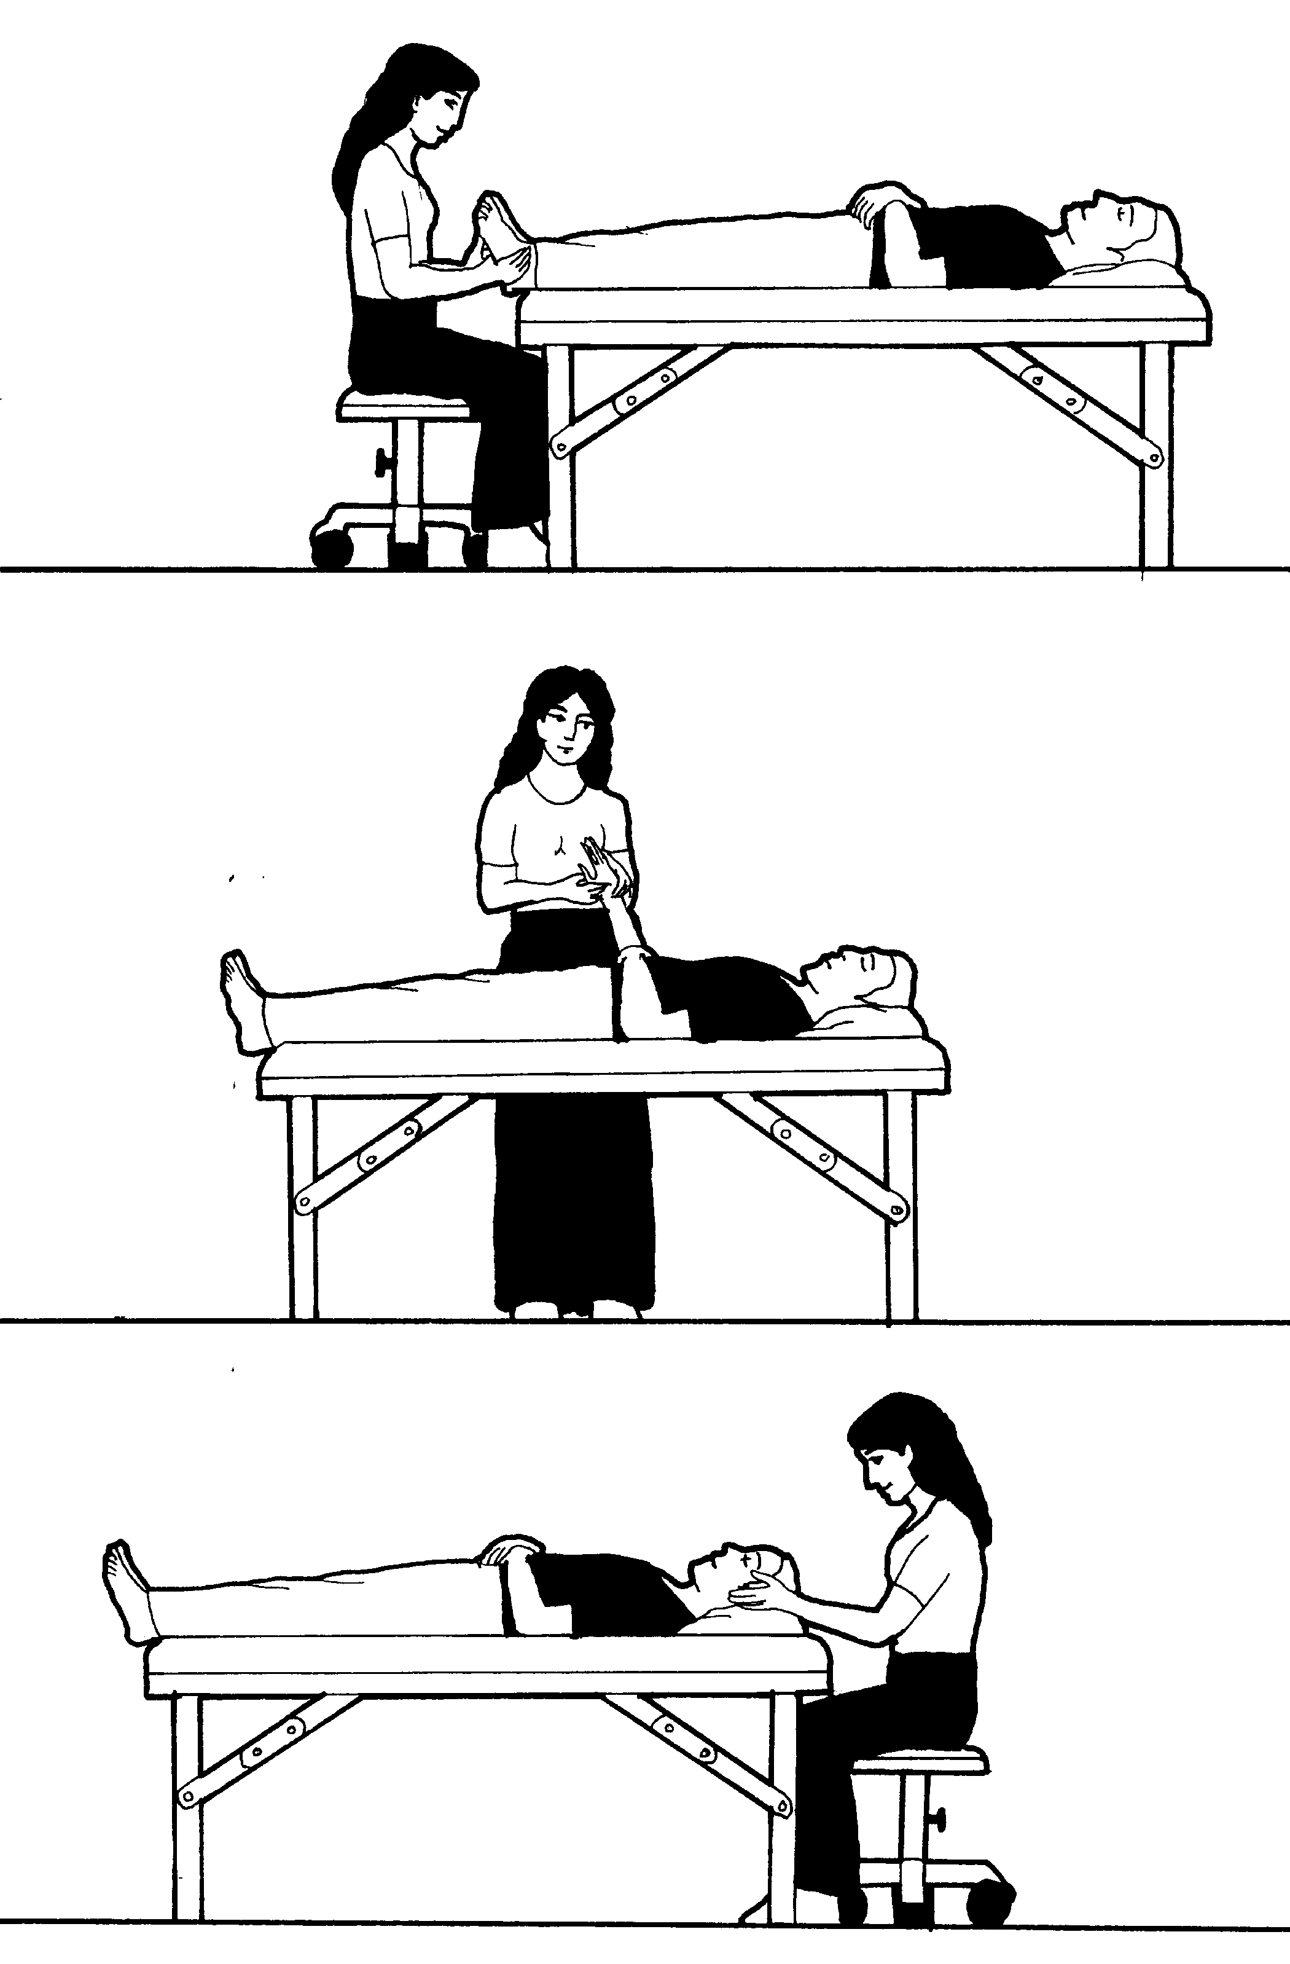

Please see School Catalog for important details, it’s on the Academy Education Web Site, or give us a call.
www.AmericanAcademyofReflexology.com

School Campus for Classes: The American Academy of Reflexology conducts it’s classes at
13315 W. Washington Blvd, LA, CA 90066 3nd Floor, TOT Room, close to Marina del Rey, Santa Monica, & LAX.
Parking: ground floor. Restaurants near by. Motel list available upon request.

Refund Policy: 100% refund if cancellation received by day prior to the start of class. Thereafter, refund will be made less a $25 fee, Or registration may be applied to future class or transferred to another person by the applicant.

Administrative Address for Correspondence & Phone Calls

American Academy of Reflexology, Bill Flocco, Director, 12719 Sarah Street, Studio City, CA 91604
818 841-7741 AAReflex@aol.com www.AmericanAcademyofReflexology.com
Class size is limited. We look forward to meeting you and sharing this adventure with you.

Scan Mail or Call Your Registration Today FHE Aug 1-2, 8-9, 2015
You can also Register online: www.AmericanAcademyofReflexology.com

If paying by check, please print your name ________________________________________________________
Please make checks payable to American Academy of Reflexology

Address __________________________________ City ____________________ State _______ Zip _________
Phone (Home) (_____) ______________ (Work) (_____)________________ (Cell) (______)________________
eMail Address _______________________________________________________________________________
Credit Card Visa MasterCard
Credit Card # ___________________________________________________ Expiration date _______________
Name On Card (Please print) ___________________________________________________________________

If payment received 4 weeks Late registrations
prior to start of seminar or at the door
Foot Hand Ear Seminar $420 $470
Foot Reflexology $210 $235
Hand & Ear Reflexology $210 $235

