Beginning Foot Hand Ear Reflexology& Certificate Course

CE Hours:28 CE HoursforARCB, ABMP, NCBTMB& Many States

Foot Reflexology Class Aug 21-22  Hand & Ear Reflexology Class Aug 23-24  9:00 AM - 5:30 PM Both Days  Help yourself, your family, friends, & clients to be pain free& have far better health. Learn effective Foot, Hand, & Ear Reflexology Routines to use separately or combine with other modalities. Working with all three is far more effective than just Foot Reflexology. Instructor, Bill Flocco.  Become A Certified Reflexologist  The more serious student can deepen their knowledge, skills,  confidence & results, after the Foot Hand Ear Class, by continuing with:  Beginning Integrated Foot Hand Ear Reflexology  Oct 3-5, 17-19, 2015 50 CE Hours  Advanced Integrated Foot Hand Ear Reflexology  Oct 31-Nov 2, Nov 21-23, 2015 50 CE Hours  Instructors: Lisa Chan, Bill Flocco, Stefanie Sabounchian | 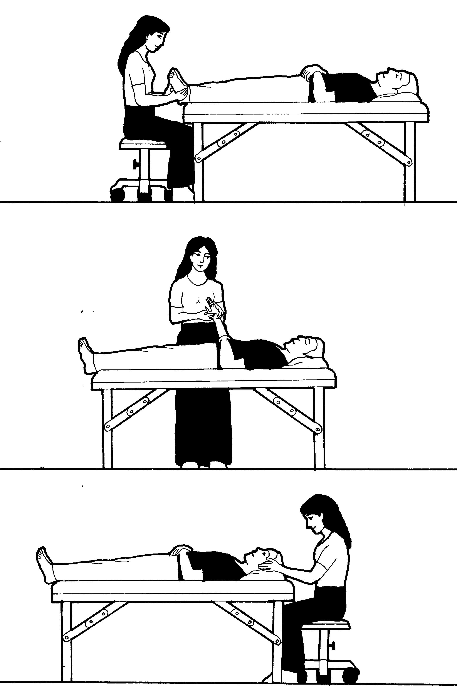

Please see School Catalog for important details, it’s on the Academy Education Web Site, or give us a call.
www.AmericanAcademyofReflexology.com

School Campusfor Classes: The American Academy of Reflexology conducts it’s classes at
13315 W. Washington Blvd, LA, CA 90066 3nd Floor, TOT Room, close to Marina del Rey, Santa Monica, & LAX.
Parking: ground floor. Restaurants near by. Motel list available upon request.

Refund Policy: 100% refund if cancellation received by day prior to the start of class. Thereafter, refund will be made less a $25 fee, Or registration may be applied to future class or transferred to another person by the applicant.

Administrative Addressfor Correspondence & Phone Calls

American Academy of Reflexology, Bill Flocco, Director, 725 E. Santa Anita Ave, #B, Burbank, CA 91501
Off 818 841-7741, Fax 818 841-2346, eMail: AAReflex@aol.com www.AmericanAcademyofReflexology.com
Class size is limited. We look forward to meeting you and sharing this adventure with you.

Fax Scan Mail or Call Your Registration Today
REGISTRATION FORM For Foot Hand Ear Reflexology Seminar Aug 21-22, 23-24, 2015

If paying by check, please print your name ________________________________________________________
Please make checks payable to American Academy of Reflexology

Address __________________________________ City ____________________ State _______ Zip _________
Phone (Home) (_____) ______________ (Work) (_____)________________ (Cell) (______)________________
eMail Address _______________________________________________________________________________
Credit Card VisaMasterCard
Credit Card # ___________________________________________________ Expiration date _______________
Name On Card (Please print) ___________________________________________________________________

If payment received 4 weeks Late registrations
prior to start of seminar or at the door
Foot Hand Ear Seminar $420 $470
Foot Reflexology $210 $235
Hand & Ear Reflexology $210 $235

