2015
Welcome To The
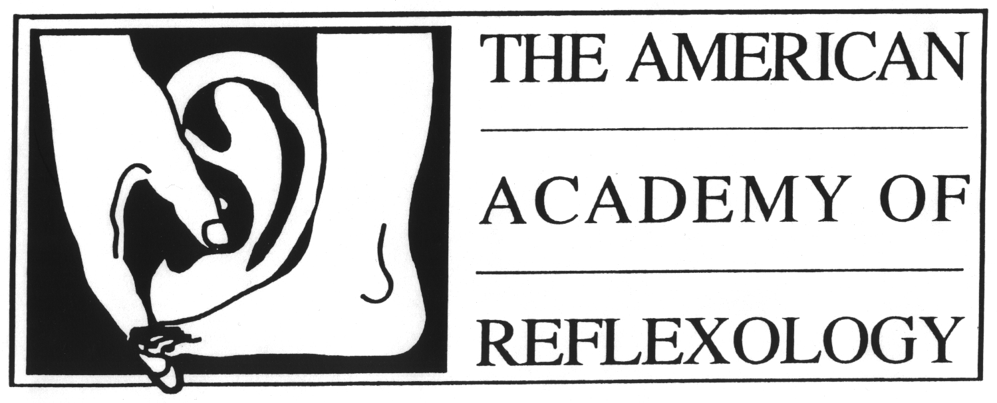
Pioneering the Integration of Foot Hand Ear Reflexology Since 1982

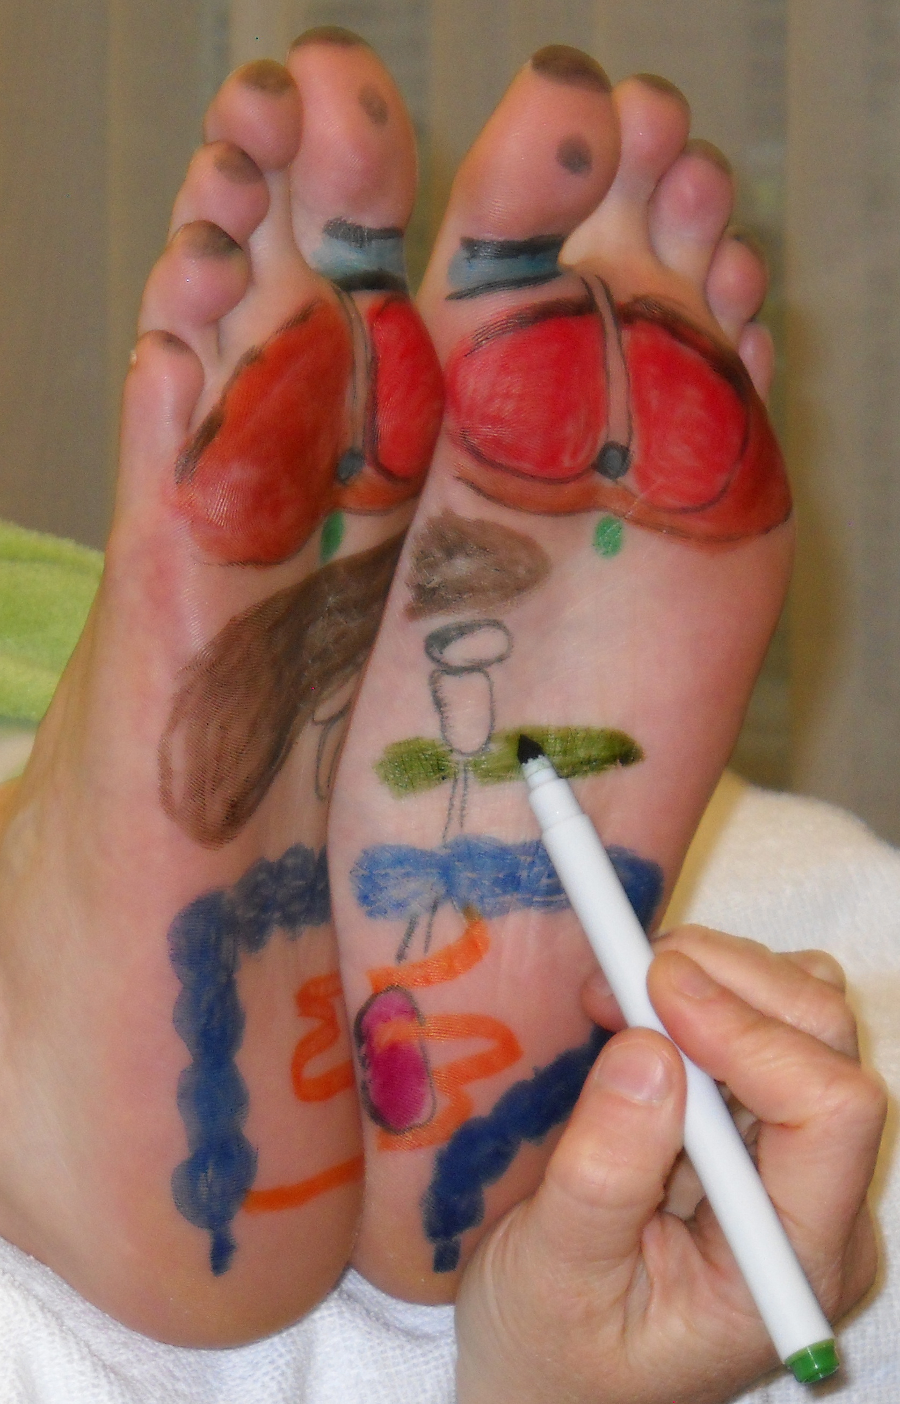 | 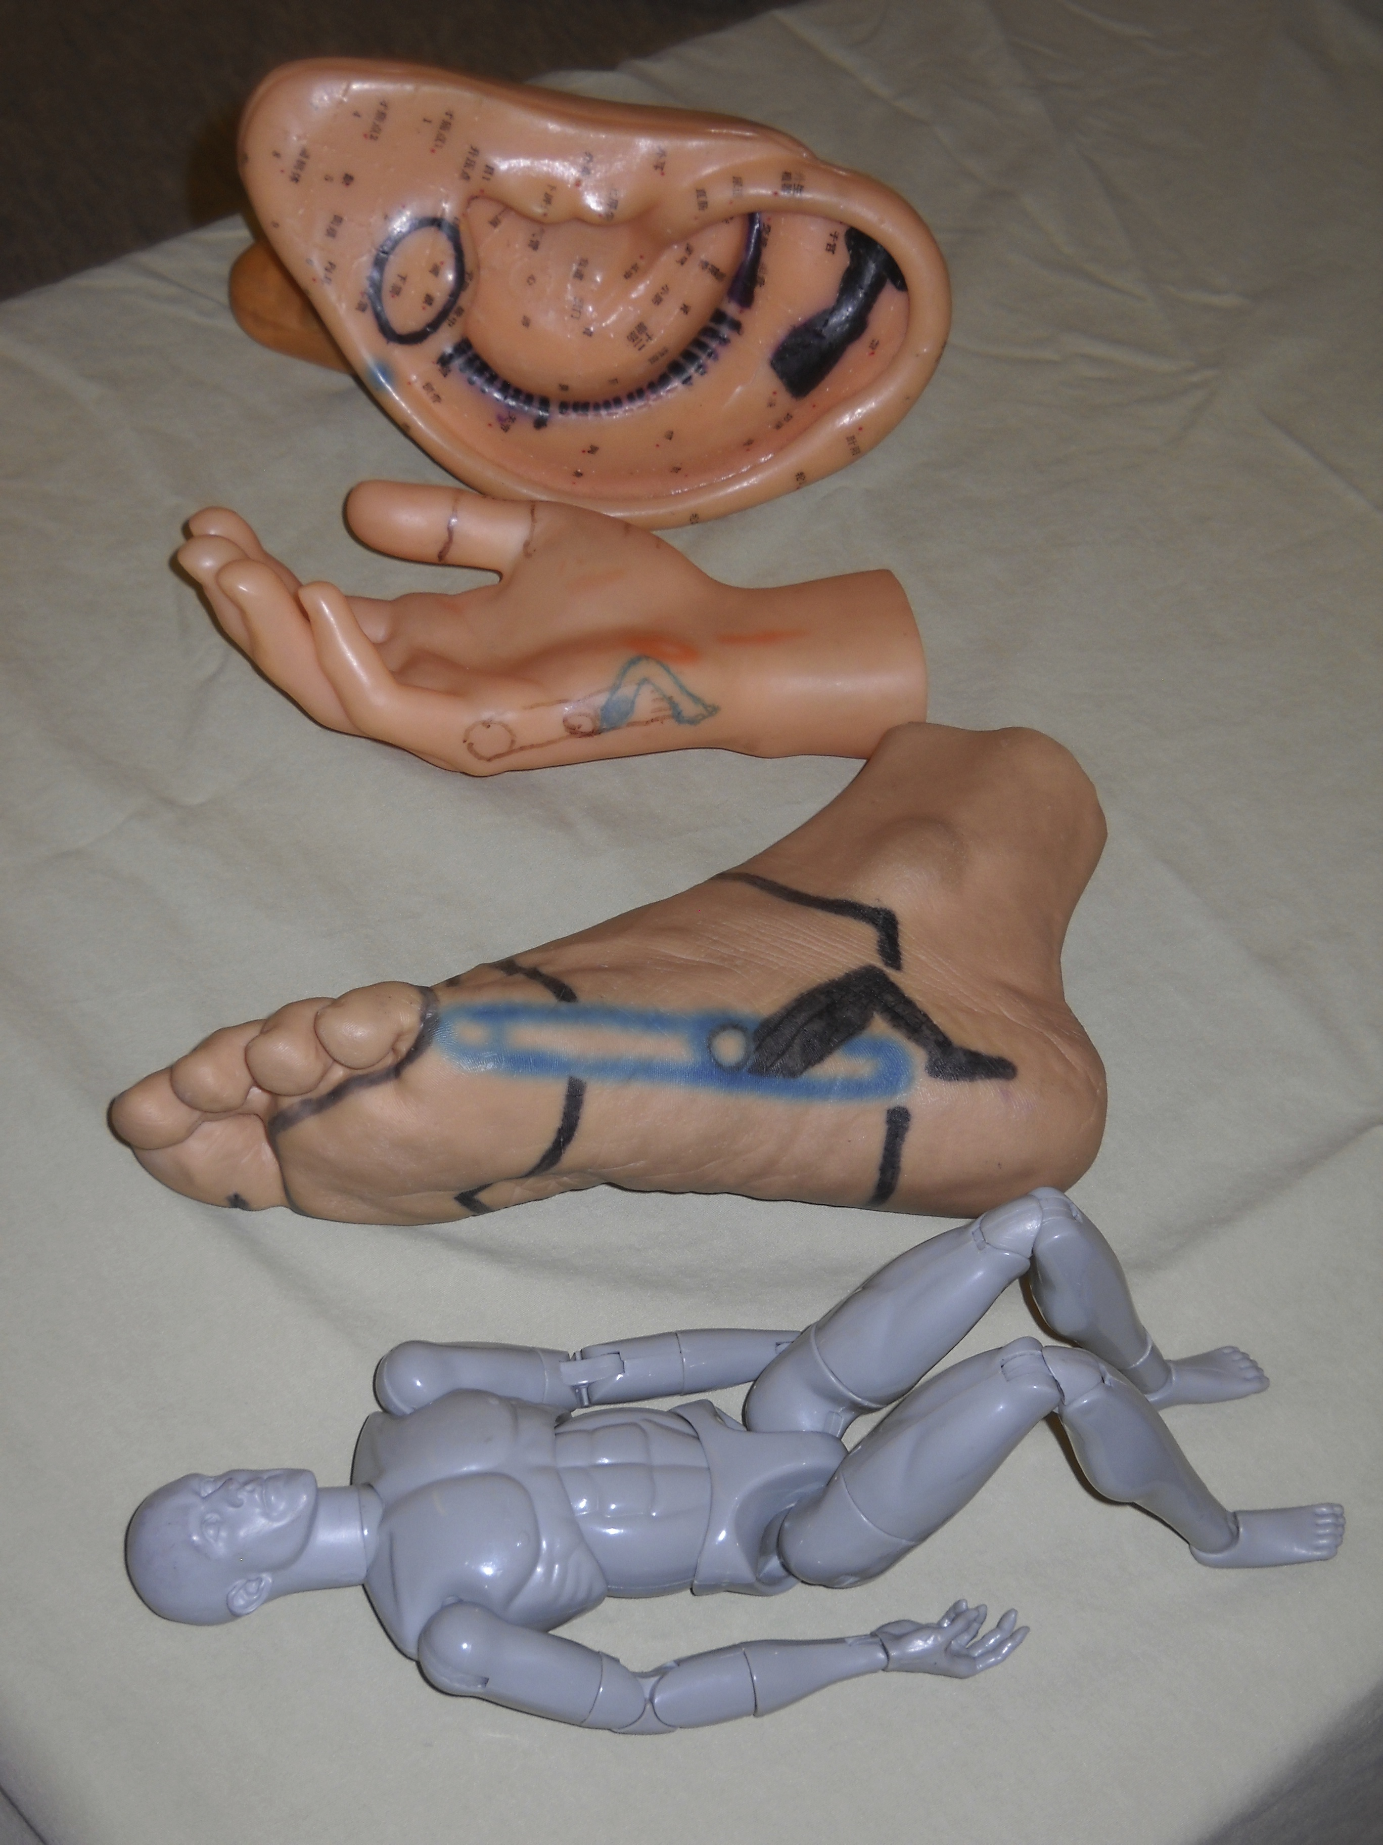 | 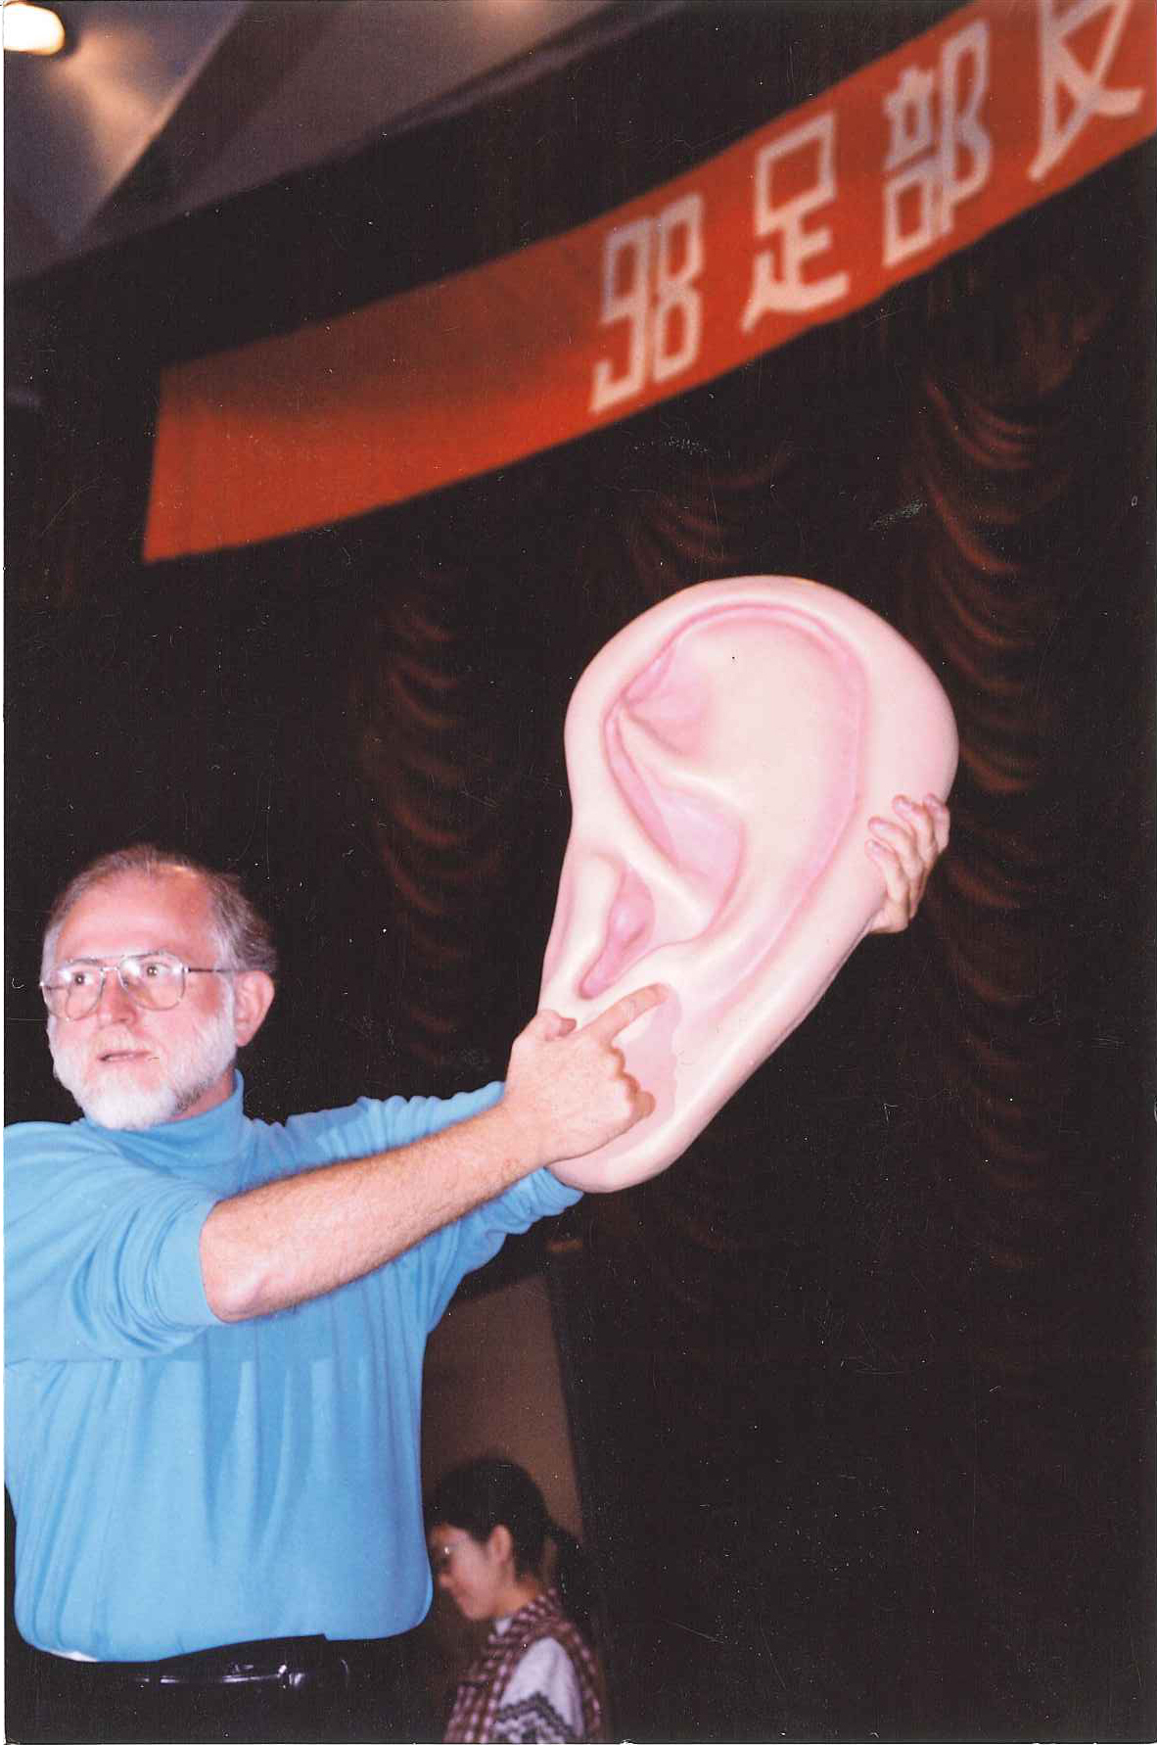

Classes For Beginners & Professionals

- Beginning Foot Hand Ear Reflexology
- Beginning Integrated Foot Hand Ear Reflexology Course
- Advanced Integrated Foot Hand Ear Reflexology Course

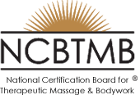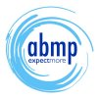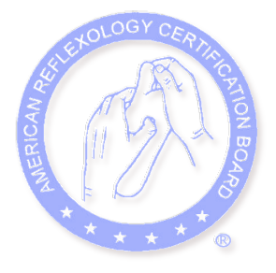
Continuing Education Hours for NCBTMB, ABMP, ARCB

Visit us on the Web
www.AmericanAcademyofReflexology.com www.ReflexologyResearch.net

School Catalog - Effective January - December 2015

General Information | Page 2
Beginning & Certificate Course Overview | Page 5
Beginning Foot Hand Ear Reflexology Course Instructional Content | Page 5
Beginning Integrated Foot Hand Ear Reflexology Course Instructional Content  Advanced Integrated Foot Hand Ear Reflexology Course Instructional Content | Page 6
Beginning Integrated & Advanced Integrated Course Fees, Dates, Times | Page 7
Meet Your Highly Skilled & Experienced Instructors | Page 8
All Classes At A Glance | Page 10
Instructional Content For All Classes | Page 10
Why You Can Have Confidence In What You Will Learn | Page 12
Registration Form | Page 13

School Campus Location: 13315 Washington Boulevard, Los Angeles, CA 90066. (3rd Floor, TOT Room)
In West Los Angeles, near Marina del Rey, close to the San Diego (405) and Santa Monica (10) Freeways,
Only 12 Minutes from the Los Angeles Airport (LAX)

All Correspondence & Phone Calls - Administrative Address: 12719 Sarah Street, Studio City, CA 91604
www.AmericanAcademyofReflexology.com 818 841-7741 AAReflex@aol.com
www.ReflexologyResearch.net

The American Academy of Reflexology is:

 Approved by the American Reflexology Certification Board (ARCB) Continuing Education Approved Provider Number 00100
 Approved by the National Certification Board for Therapeutic Massage and Bodywork (NCBTMB)
NCBTMB Continuing Education Approved Provider Number 385298-00
 All Continuing Education Hours Accepted by The Associated Massage & Bodywork Professionals (ABMP)

Ownership The American Academy of Reflexology is a sole proprietorship of Bill Flocco, Founder/Director.

Mission The American Academy of Reflexology is dedicated to improving the quality of life around California, the United States of America, and the world, by providing the highest quality educational program to all adults interested in the study of Reflexology. The Academy is totally dedicated to our students having a highly successful learning experience and to helping our graduates become exceptionally successful practitioners of Reflexology.

Objectives The objective of our Instructional Program is to provide the student with an understanding of the fundamentals of Reflexology, including an understanding of the history and theory behind Reflexology. It involves hands-on techniques that provide students with practical experience in the successful application of Foot, Hand, and Ear Reflexology for the beginner, for the professional Reflexologist, and for practitioners of other modalities who would like to add Reflexology to their practice so as to better help their clients or patients.

Licensing & Continuing Education As of January 18, 2012 The American Academy of Reflexology has officially been granted an Exemption, by the State of California, Bureau for Private Postsecondary Education (BPPE). Although instructional hours do not count toward licensing, however most classes count toward Continuing Education (CE) Hours with American Reflexology Certification Board (ARCB), National Certification Board for Therapeutic Massage & Bodywork (NCBTMB), Associated Massage & Bodywork Professionals (ABMP).

Reflexology As An Occupation Many people study Reflexology to use on themselves, their families, and friends. Additionally, Reflexology is rapidly emerging around the USA and the world, having been featured on many TV talk shows, in numerous magazines and books, has professional Reflexology organizations, international Reflexology symposia and conferences, extensive published research, and is recognized by both the White House Commission on Complementary and Alternative Medicine, as well as the National Institutes for Health.

Everyone can practice Reflexology. We have been teaching Reflexology to people from all walks of life for 30 years. Our instructional program is designed to help you become a highly knowledgeable, skilled, and effective practitioner of The “Flocco Method – Integrated Foot Hand Ear Reflexology.” Our instruction is for Beginners with no prior training in the touch therapies, as well as for people from professions such a Massage Therapy, Bodywork, Cosmetology, Physical Therapy, Nursing, and others, who have studied with us so as to incorporate Reflexology into their practices and professions, and to have additional ways to help their clients and patients.

Full Time vs. Part Time Profession Most people who practice Reflexology professionally, do so on a part time basis and are self-employed. The income a practitioner achieves is primarily dependent on their personal diligent efforts. If you decide to practice full time, we encourage you to build your practice on a part time basis, keeping your current employment, until income from your Reflexology practice is abundant enough to replace your current income.

Nondiscrimination Students are admitted without regard to race, color, sex, religion, age, national origin, or disability (as long as the student has the capacity to perform the hands-on skills normally required of a practitioner in the field of Reflexology).

Student Counseling It is our desire for the student to succeed in their studies at the American Academy of Reflexology (AAR). To that end, the instructor works closely with each student throughout the course. Students requiring special assistance are encouraged and invited to bring their special learning needs to the attention of the instructor.

Placement Services Since Reflexologists are self-employed, placement services are not available. However, whenever the Academy receives a call from someone wanting Reflexology, the caller is either given the names of Reflexologists in their area, or a Reflexologist is called, to respond to the interested party. When someone is looking for a Reflexologist to work at a facility, we either give the caller the names of Reflexologists in the area, or call Reflexologists in the area, giving them the number of the person making the request.

Hotels and Motel Accommodations For students traveling to class from other parts of California, other states or countries, who would like hotel or motel accommodations, a list of hotels and motels is available upon request.

Admission To be admitted to classes, the student must be a high school graduate or at least 18 years of age, tour the school, receive certain disclosures and sign an enrollment agreement - which is done the first day of class. Students under the age of 18 are only admitted with written parental consent and approval of the Academy Director.

Credit for Prior Experience Although the Academy acknowledges the value of prior experience, because of the unique nature of our entire training program, credit for past experience is not available. The Director may take into account unique situations.

Credit for Prior Classroom Instruction Some workshops require no prior classroom instruction, however, some advanced Workshops require prior classroom instruction from a hands-on school. The Academy Director makes final determination if specific prior hands-on instruction qualifies. Please see each Course and Workshop for requirements.

Students From Other Countries Students from other countries are advised that all classes are conducted in English, that all legal entry and residency requirements are the responsibility of and the expense of the student. Conversations will need to be conducted ahead of time, between the prospective student and the Director, to determine if the student has an acceptable level of English proficiency to ensure successful participation and completion of the full course of study.

ESL Instruction This institution does not provide English as a Second Language (ESL) instruction.

Attendance Because of the highly participatory nature of the Academy program, students will gain the greatest amount of learning by attending every hour of class. For shorter classes (one and two day classes) credit will be given for actual classroom hours attended. For Beginning Integrated Foot Hand Ear Reflexology and Advanced Integrated Foot Hand Ear Reflexology Courses, students must attend at least 70% of Classroom Hours - students will need to make up hours missed. Make up can be discussed with the Director.

Tardiness Instruction presentations are limited to small groups, usually under 25 students, so as to ensure that each student receives individualized attention from the instructor. When students come to class tardy, it can be disruptive to the flow and distracting to the sensitive nature of the subjects that we deal with in class. Consequently, arriving at class early helps enhance the learning process. Students more than 15 minutes late will not receive credit for that hour of instruction. Students will need to make up time missed through tardiness. Make up can be discussed with the Director.

Dropout Students dropping out of a course may receive a tuition refund based upon our refund policy outlined in this catalogue. The last day of classes attended will be considered the date of cancellation, whether or not a cancellation notice is given by the student to the Director.

Leave-of-Absence Students may request a leave of absence in the event of illness, family emergency, or other compelling reasons. The student may then be admitted to a later course when they are covering the same material that was missed. If the student would like to review the part of the course they already took, the fee will be only 50% of the per-diem fee at the time of review. Fees for the part of the course that was not yet taken will reflect the per-diem fees at the time of attending the rest of the course.

Student Conduct Any student may be dismissed by the Director for any behavior that could lead to injury, or which could damage the school facilities or disrupt the instructional or learning environment or other operations of the school. Intoxication, drugged behavior, behavior deemed inappropriate, possession of a weapon or behavior creating a safety hazard to other persons at the school, or repeated absence without valid excuse are grounds for immediate dismissal.

Complaint Resolution If you find you have a problem at the American Academy of Reflexology, please discuss the problem with your instructor. The school is dedicated to providing you with an enjoyable atmosphere that helps you to learn. If for any reason you are unable to resolve the matter, you may submit a written complaint to: The American Academy of Reflexology, 725 E. Santa Anita Avenue, Suite B, Burbank, CA 91501-2964. The written complaint should contain your name and address, the nature of the problem you encountered, the date the problem occurred or began, the names of individuals involved in the problem, copies of documents, if any, which contain information regarding the problem, evidence that, or an assertion that the complaint procedure was properly followed. To the degree possible, a response will be sent to you within 10 days.

Federal and State Funding This institution does not participate in federal and state financial aid programs.

Student’s Right To Cancel The institution, for all students, without penalty or obligation, shall refund 100% of the amount paid for institutional charges, less any registration fee, if notice of cancellation is made prior to or on the first scheduled day of instruction. The institution advises each student that any notification of withdrawal or cancellation and any requests for a refund must be made in writing.

Specialized Instructional Materials & Equipment Specific materials have been developed for each Course and Workshop and are included in the class fee. For the 28 Hour Beginning Foot Hand Ear Reflexology Course, workbooks, charts, and illustrations of hands-on routines are included. For the Beginning Integrated Foot Hand Ear Reflexology Course and Advanced Integrated Foot Hand Ear Reflexology Course, an extensive Integrated Foot Hand Ear Reflexology Manual containing written text, workbook exercises, study guides, extensive use of illustrations, photographs, charts and other special features, is included. There is a place at the beginning of the Manual for all workbooks, charts, and routine illustrations from the Beginning Foot Hand Ear Reflexology class. Some visual aids used are: charts, overhead projector, models of feet, hands, ears, human body, and other two and three dimensional learning aids. Most hands-on work is done using comfortable Reflexology tables.

Library & Reference Materials Although we do not have a library, a variety of reference materials are brought into class. During the course a list of reference books is provided, with an explanation of how and when they might best be used by a Reflexology practitioner.

Record Retention Student records are retained for 5 years. Transcripts available upon request for a minimal fee.

Beginning, Beginning Integrated & Advanced Integrated Course Overview

- Beginning Foot, Hand, and Ear Reflexology (28 hours) Document of Attendance
- Beginning Integrated Foot Hand and Ear Reflexology (50 Hours) Certificate of Attendance
- Advanced Integrated Foot Hand and Ear Reflexology (50 Hours) Certificate of Attendance
- Examination Written and practical examination are given to help students demonstrate their command of both the academic as well as the practical hands-on art, science, and technology of highly effective Reflexology skills. The final examination is conducted either the next to last day or the last day of the Advanced Integrated Foot Hand and Ear Reflexology Course. If the student does not pass the written test because of learning difficulties with the written word, testing can be conducted orally. What we care about most, is that the student, in one way or another, is able to demonstrate having learned appropriate principles, theories, and applicable knowledge as covered in class. Passing score on the written exam is 75%. If a part of the exam is not passed, the student can retake that portion. Please be assured that most students pass the exam the first time.

Learning Through Study Groups Although not required, all students are strongly encouraged to get together with study groups from the general geographic area where they live or work. The main benefits of study groups are: 1) working on someone, between class meetings, who can give the type of feedback that only someone else from class can give; 2) receiving Reflexology between classes, so you can personally experience the deeper benefits for regular, on-going Reflexology sessions; 3) moral support and encouragement; 4) a support group to help you, between class meetings, to think through specific situations experienced with Reflexology; 5) support in studying the academic aspects of the course: 6) develop a camaraderie that, for many graduates, lasts years after completing the course. Students who actively participate in study groups, almost always score higher on their final examinations.

You will learn an entire new body of knowledge that is called the “Flocco Method-Integrating Foot Hand Ear Reflexology.” This method of Reflexology has been developed since 1981, and has been taught on four Continents: Australia, Canada, China, Germany, Holland, New Zealand, Switzerland, and across America. The Flocco Method is the only method of Reflexology to be validated in published scientific literature, through a randomized controlled peer review study conducted at the Academy and reported in the highly prestigious medical research journal, “Obstetrics & Gynecology,” Dec. 1993.

Beginning Foot Hand Ear Reflexology 28 Hours Instructional Content

Foot Reflexology Day 1 & 2 14 Hours
- Documented History  - Three Primary Theories  - Foot Reflexology Map  - Causes of Tenderness (actual and theoretical)  - Special approaches for supporting feet while working on the client  - 6 reflexing techniques | - One hour hands-on Foot Reflexology routine  as the basis of a flexible approach to reflexing  - How much pressure  - Cautions / Contraindications  - Numerous benefits  - Introduction to pulses  - Advantages of Foot Reflexology

Hand Reflexology Day 3 7 Hours
- History and theories  - Western hand Reflexology map  - Similarities between hands and feet  - Major differences between hands and feet  - Causes of Tenderness (actual and theoretical)  - Special approaches for supporting hands  while working on the client | - 6 reflexing techniques  - One hour hands-on Hand Reflexology routine as the basis of a flexible approach to reflexing  - How much pressure  - Cautions  - Contraindications  - Advantages of Hand Reflexology

Ear Reflexology Day 4 7 Hours
- Documented History  - Two theories  - Difference between ear Reflexology and  Auriculotherapy  - Structures of outer ear  - Integration of French and Chinese charts  - 5 vital “Master Points” location and use | - Five specialized touch techniques  specifically for the outer ear  - One hour Ear Reflexology routine as the  basis of flexible approach to reflexing  - Beginning exploration of the subtle pulses  of the outer ear  - Dramatic advantages of Ear Reflexology

After completing the above 28 Hour Foot Hand Ear Reflexology Course
You can elect to continue with Beginning Integrated Foot Hand Ear Reflexology Course.

Beginning Integrated
Foot Hand Ear Reflexology
Instructional Content
50 Hours

- Advanced Foot Reflexology Routine  - Advanced Hand Reflexology Routine  - Advanced Ear Reflexology Routine  - Anatomy from the point of view of the Reflexologist  - Reflexing for 6 of 12 Anatomical Systems  - Reflexing for the Seven Reflexology Regions | - Introduction to “Priority Reflexing” - When Feet or Hands or Ears are more effective  - Introduction to “Progression Reflexing” 6 Targeted Integrated Foot Hand Ear Reflexology Routines for pain in specific parts of the body  - Introduction to use of Client History Forms  - Code of Ethics

After completing the above Beginning Integrated Foot Hand Ear Reflexology Course
You can elect to continue with Advanced Integrated Foot Hand Ear Reflexology Course.

Advanced Integrated
Foot Hand Ear Reflexology
Instructional Content
50 Hours

- General One Hour Integrated Foot Hand Ear Reflexology Routine  - Four Ways to Modify Foot Hand Ear & Integrated Routines based on each person’s ever changing needs  - Continue with “Progression Reflexing” 6 more Targeted Integrated Foot Hand Ear Reflexology Routines for pain in specific parts of the body  - Reflexing For 6 more Anatomical Systems  - Light Pressure and Hard Tissue Reflexing Techniques | - What Parts of the body help other parts to work better  - Five ways to measure client progress  - Advanced use of Client History Forms  - How to Build a Thriving Practice  - How to Maintain a Successful Practice  - Business and Marketing Skills  - Legal and Licensing Issues  - How to be an Exceptionally Effective Practitioner of the Integration Of Foot Hand Ear Reflexology

Beginning & Integrated Courses: Fees

Beginning Foot, Hand, and Ear Reflexology ……………………. 28 Hours
Beginning Integrated of Foot Hand and Ear Reflexology ……... 50 Hours
Advanced Integrated of Foot Hand and Ear Reflexology ……... 50 Hours
Total 128 Hours

- Beginning Foot, Hand, and Ear Reflexology (28 hours). For Beginners & Professionals
$420 one month before class, $470 thereafter

- Beginning Integrated Foot Hand and Ear Reflexology (50 Hours). This can be taken after the Beginning Foot Hand Ear Reflexology Course. It can be taken without continuing with the Advanced Integrated Foot Hand Ear Reflexology Course. However, it is required before taking the Advanced Integrated Foot Hand Ear Reflexology Certificate Course.
* Prerequisite: The above 28 Hour Beginning Foot Hand Ear Reflexology Course from The Academy or equivalent instruction from a hands-on school.
$775 by August 2, $825 thereafter
Registration Fee: $25 by August 2, $75 thereafter.

- Advanced Integrated Foot Hand and Ear Reflexology (50 Hours).
** Prerequisite: The above Beginning Integrated Foot Hand Ear Reflexology Course from an Academy Authorized Instructor.
$775 by August 2, $825 thereafter

- If you sign up for both the Beginning and Advanced Integrated Foot Hand Ear Reflexology Courses, your fees will be:
$1550 by August 2, $1650 thereafter
Registration Fee: $25 by August 2, $75 thereafter

The non-refundable Registration Fees covers cost of processing the application, record keeping, and related administrative costs. Based on individual needs, payment plans can be tailor-made, by mutual agreement.

Refund Policy The refund policy for students who have completed 50% or less of each course shall be a pro rata refund. Thereafter there will be no refund.

Beginning & Integrated Courses: Dates & Times 2015

Beginning Foot Hand Ear Reflexology (28 Hours)
March 14-15, 21-22, Repeated August 1-2, 8-9, Sat & Sun 9:00 - 5:30

Beginning Integrated Foot Hand Ear Reflexology (50 Hours)
(Five Days) August 17-21 Monday – Friday 8:00-7:00
* Prerequisite: At least 28 Hours of Beginning Foot Hand Ear Reflexology from AAR or another hands-on school

Advanced Integrated Foot Hand Ear Reflexology (50 Hours)
(Five Days) August 24-28 Monday – Friday 8:00-7:00
** Beginning Integrated Foot Hand Ear Reflexology from the Academy

Meet Your Highly Skilled & Experienced Instructors

Some of the classes taught by our Instructors are offered every other year.

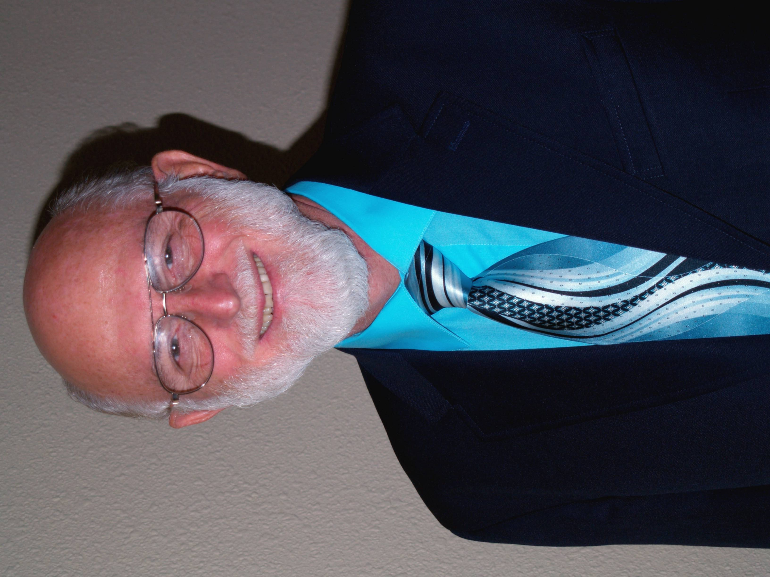 | Bill Flocco, Founder/Director of the American Academy of Reflexology, has been a teacher in the fields of health and education for over 30 years. Bill has taught “The Flocco Method: Integrating Foot, Hand & Ear Reflexology” on four continents, in Australia, Canada, China, Germany, the Netherlands, New Zealand, Switzerland, and across the USA. He is past President of the International Council of Reflexologists, Founder of World Reflexology Week, author of Reflexology Books, Workbooks, Manuals, is a leading published Reflexology Researcher, and strong advocate on behalf of the Reflexology Profession.
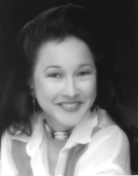 | Lisa Chan Lisa earned her Full Reflexology Certificate from the American Academy of Reflexology in 1991 and has been teaching Academy classes in various parts of California and the USA since 1995. Lisa is a licensed Acupuncturist, has an active Reflexology and Acupuncture practice in the Greater Los Angeles area, has conducted the popular Beginning and Integrated Certificate Course, Spa Reflexology, Infant, Child, Teen Reflexology, and other classes for many years. She hosted her own cable TV show called “Healers on Healing,” was editor of the “Reflexology Digest” for the Reflexology Association of California, and author of Reflexology Coloring Book.
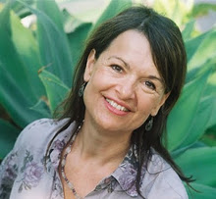 | Maryejo Del Meijer is one of the world’s leading experts in the natural science of Metamorphosis. Maryejo has a BA in Early Childhood Education, a Masters Degree in Spiritual Psychology, and another Masters Degree in Family Counseling and is certified Body Worker. Maryejo has the unique distinction of having lived with the Robert St. John family for two years. St. John discovered and developed the Metamorphic Technique and personally instructed Maryejo in this gentle, yet profoundly powerful method. As a practitioner of Metamorphosis for over twenty-five years, she is remarkably perceptive and unique in her field.
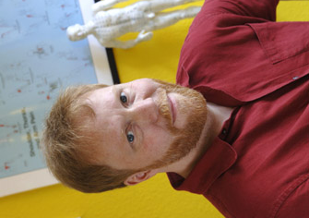 | Peter Lund Frandsen is a Reflexologist and has studied modern physics and philosophy in the USA, and medicine at University of Copenhagen. For many years Peter has been actively involved with the Danish Reflexologists Association (FDZ), where he co-ordinates the association’s international activities. He co-organized the Reflexology Network in Europe (RiEN) 2000 Reflexology Conference in Denmark. Peter is an international lecturer on energy and various aspects of Reflexology. Dorthe and Peter present workshops in Denmark, Norway, Sweden, Iceland, England, Wales, Germany, Holland, Belgium, Switzerland, Australia, South Africa and USA.
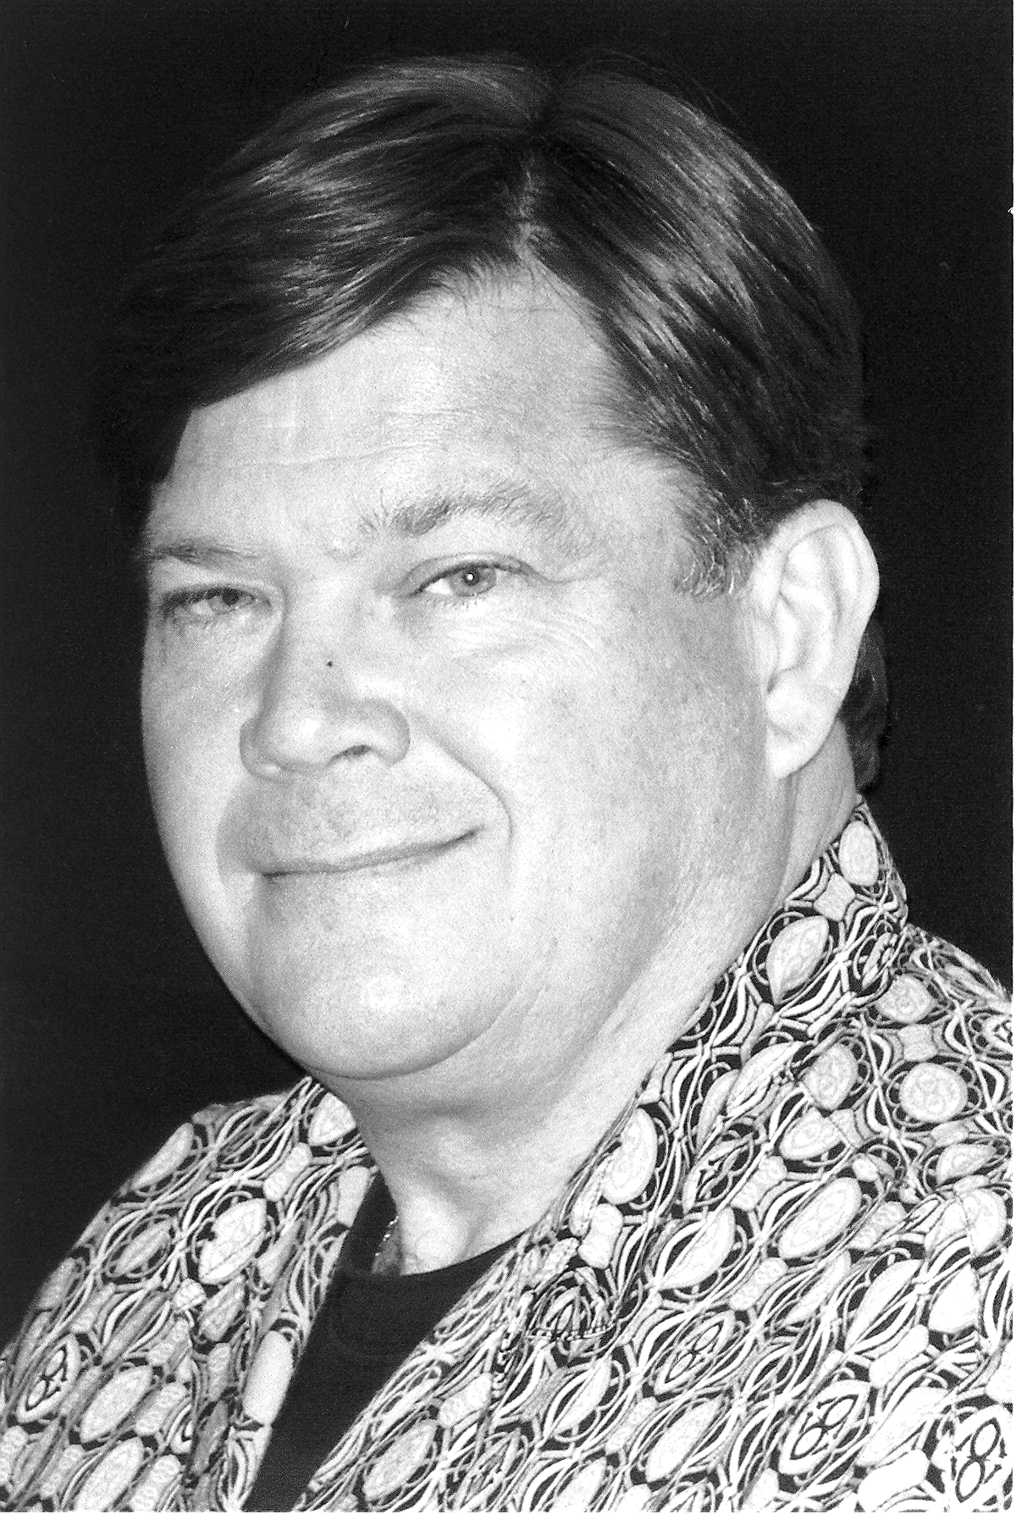 | Paul Harvey has studied with a number of Reflexology teachers, and is a graduate of the Academy. Paul is Past Chairperson of the National Health Federation, Past Board member of the Reflexology Association of California, and has been a consultant to the Reflexology Association of America. He maintains a thriving Reflexology practice and works as a Reflexologists with a team of five Doctors at the world famous Whittaker Clinic in Southern California. With extensive experience as a Clinical Reflexologist, Paul teaches a variety of “Condition Specific” workshops, with Foot Hand Ear Reflexology.
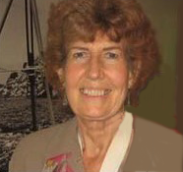 | Maureen Holdaway has studied Foot Hand Ear Reflexology as well as being Certified in Integrated Foot Hand Ear Reflexology with the Academy. Maureen is a Certified and Licensed Massage Therapist with an active practice in Los Angeles and Carpentaria, California. She has been an advanced practitioner and teacher of the King Method of Energy Healing for decades, which gives an exceptional depth and range of experiences to call upon to make her teaching all the more practical and the results her students get, all the more effective.
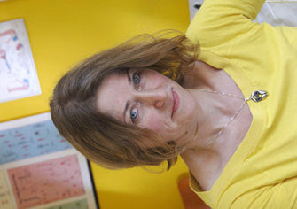 | Dorthe Krogsgaard with 24 years of experience working full time in her Copenhagen based practice, is one of the Reflexology pioneers in Denmark. Throughout her career she has always been actively involved with raising the profession’s standards and documenting its effects. Dorthe has served as chairperson for the Danish Reflexologists Association (FDZ), she was instrumental in establishing FDZ’s Research Committee in 1991 and the exceptional quality Reflexology Research that has been conducted in Denmark. She has served on the Board of Directors and Vice-President of the International Council of Reflexologists (ICR).
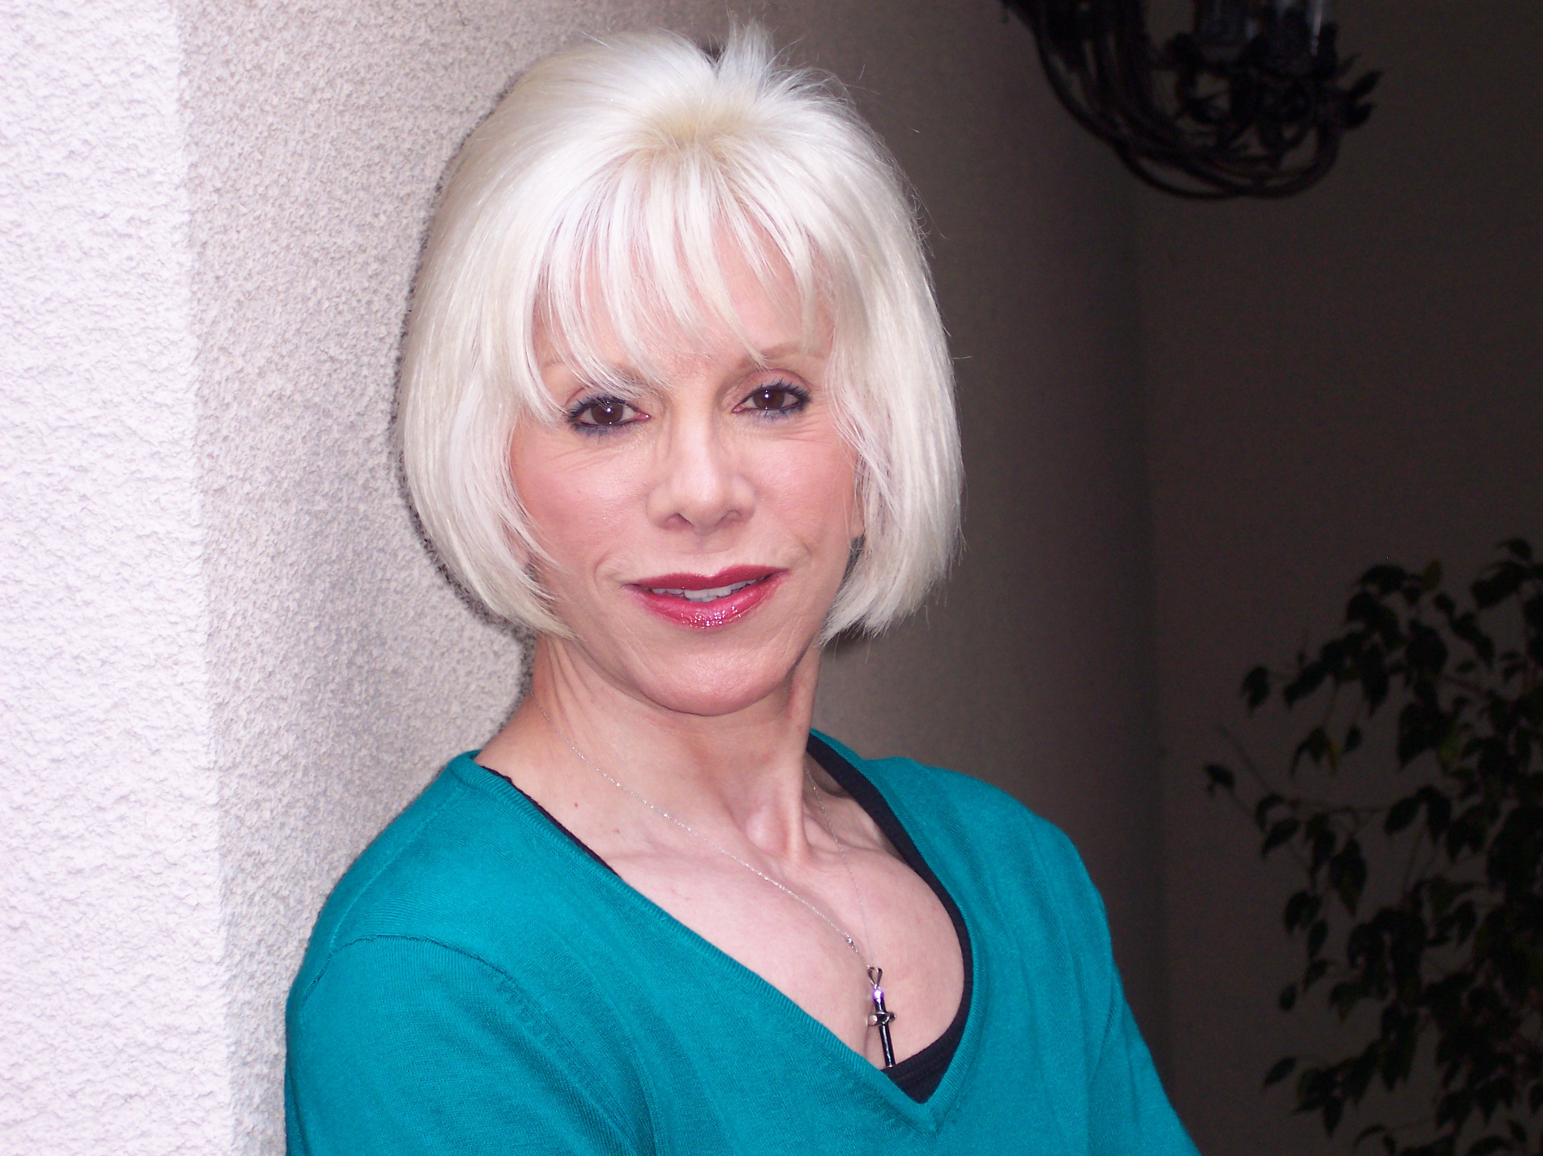 | Michele Martin-Cuatt has been a practitioner of acupressure for over 25 years, and taught Shiatsu/Acupressure at a number of Schools and Acupuncture Colleges. Michele has studied many other touch therapies and natural healing arts, especially Thai Massage and Thai Reflexology at various schools throughout Thailand. She maintains an active practice in the West Los Angeles area. Michele teaches Acupressure of the Forearms & Hands, Lower Legs & Feet as well as Thai/Chinese Reflexology here at the Academy.
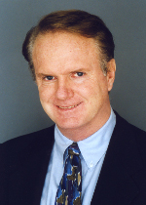 | Terry Oleson PhD, internationally know lecturer and author in the field of Auriculotherapy, received his PhD in psychobiology from the University of California at Irvine, conducted pioneering research on Auriculotherapy at the UCLA Pain Management Center in Los Angeles. Besides writing numerous scientific articles, Terry has served on the faculty of a number of Universities. He is acknowledged as one of the world’s leading experts on the power of the Reflexology maps in the outer ears. His book, Auriculotherapy Manual: Chinese and Western Systems of Ear Acupuncture is possibly the most complete book available in the field today. Terry teaches our Advanced Ear Reflexology class.
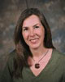 | Stefanie Sabounchian Stefanie studied and practiced Reflexology for many years in her home country of Germany before she came to the United States in 2000. She earned her Reflexology Certificate in Integrated Foot Hand Ear Reflexology from the American Academy of Reflexology in 2002, is Nationally Certified with the American Reflexology Certification Board (ARCB), is Past-President of the Reflexology Association of California (RAC), and has a thriving Reflexology practice in Southern California. Stefanie teaches Foot Hand Ear Reflexology at several area schools where her knowledge, professionalism, and sincerity endear her to her students.
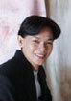 | Ko Tan earned his Full Reflexology Certification from the Academy in 1990 and has been teaching Academy classes in various parts of Georgia, North Carolina, Tennessee, and Wisconsin. Tan is a Past Board Member of the International Council of Reflexologists (ICR), the American Reflexology Certification Board (ARCB), and the Georgia Reflexology Organization (GRO). Tan has been teaching the Academy Beginning Foot Hand Ear Reflexology Course, Integrated Foot Hand Ear Reflexology Certificate Course, Face Reflexology, and other classes for many years. Tan was part of the first Reflexology research study to be published in scientific medical literature.
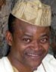 | Jude Unegbu has been a spiritual healer for over 20 years. Born in West Africa, he traveled with his Shaman grandfather, who offered healing to people afflicted with epilepsy, leprosy, depression, and other physical illnesses. He gives tirelessly of his time and efforts on behalf of those in need of Hands-on and Distance Healing. He is a Master Practitioner, has taught the King Method of Energy Healing extensively, and brings a broad understanding of different cultures to his work. Besides having gone to massage school, Jude has taken the Academy Pain Control & Stress Reduction with Foot Hand Ear Reflexology class. Jude co-teaches the Energy Healing & Aura Balancing class.
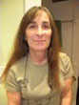 | Robin Varga Robin earned her Full Reflexology Certificate from the American Academy of Reflexology in 1994 and has been teaching Academy classes in various parts of California and other states ever since. Robin teaches Beginning Foot Hand Ear Reflexology, Spa Reflexology, and the Full Certificate Course in Northern California. Her enthusiasm, combined with a full time Reflexology and massage practice, give her a rich range of experiences to help your learning be enjoyable, practical, and deeply rewarding. Robin is Past President of the Reflexology Association of California (RAC) and for years was active on RAC Legislative Options Committee.

All Classes At A Glance 2015

Class Subject | Dates | Days | Times | CE Hours | Instructors
Beginning Foot Hand Ear Reflexology | Mar 14-15,  21-22 | Sat & Sun | 9:00 – 5:30 | 28 | Stefanie Sabounchian
Face Reflexology | Jun 6-7 | Sat & Sun | 9:00 – 5:30 | 14 | Ko Tan
Beginning Foot Hand Ear Reflexology | Aug 1-2, 8-9 | Sat & Sun | 9:00 – 5:30 | 28 | Lisa Chan
* Beginning Integrated Foot Hand Ear Reflexology Certificate Course | Aug 17-21 | Mon - Fri | 8:00 – 7:00 | 50 | Chan, Flocco, Sabounchian
** Advanced Integrated Foot Hand Ear Reflexology Certificate Course | Aug 24-28 | Mon-Fri | 8:00 – 7:00 | 50 | Chan, Flocco, Sabounchian
Acupressure of the Extremities | Sep 19-20 | Sat & Sun | 9:30 – 5:00 | 12 | Michele Martin-Cuatt
*** Stroke, Diabetes, Parkinson’s, Fibromyalgia, Cardiovascular Diseases | Nov 14-15 | Sat & Sun | 9:30 – 5:00 | 12 | Paul Harvey

* Prerequisite: At least 28 Hours of Beginning Foot Hand Ear Reflexology from a hands-on school
** Beginning Integrated Foot Hand Ear Reflexology from the Academy
*** Beginning Foot Hand Ear Reflexology from a hands-on school

Instructional Content For All Classes 2015

All CE Classes (except where noted) NCBTMB, ABMP, ARCB

1. Beginning Foot Hand Ear Reflexology Intensive March 14-15, 21-22
$420 if paid at least one month early, $470 thereafter
Saturday & Sunday, 9:00 AM – 5:30 PM
For Beginners and Professionals: 28 CE Hours for ARCB, NCBTMB, ABMP, and many States.
Beginning Foot Reflexology Documented History, Three Primary Theories, Foot Reflexology Map, Causes of Tenderness (actual and theoretical), Special approaches for supporting feet while working on the client, 6 reflexing techniques, One hour hands-on Foot Reflexology routine as the basis of a flexible approach to reflexing, How much pressure, Cautions / Contraindications, Numerous benefits, Introduction to pulses, Advantages of Foot Reflexology
Beginning Hand Reflexology History and theories, Western hand Reflexology map, Similarities between hands and feet, Major differences between hands and feet, Causes of Tenderness (actual and theoretical), Special approaches for supporting hands while working on the client, 6 reflexing techniques, One hour hands-on Hand Reflexology routine as the basis of a flexible approach to reflexing, How much pressure, Cautions / Contraindications, Advantages of Hand Reflexology
Beginning Ear Reflexology Documented History, Two theories, Difference between ear Reflexology and Auriculotherapy, Structures of outer ear, Integration of French and Chinese charts, 5 vital “Master Points” location and use, Five specialized touch techniques specifically for the outer ear, One hour Ear Reflexology routine as the basis of flexible approach to reflexing, Beginning exploration of the subtle pulses of the outer ear, Dramatic advantages of Ear Reflexology
Instructor: Stefanie Sabounchian

2. Face Reflexology June 6-7
$320 if paid at least one month early, $340 thereafter.
Saturday & Sunday, 9:00 AM – 5:30 PM
For Beginners and Professionals: 14 CE Hours for ARCB, NCBTMB, ABMP, and many States.
Facial Reflexology is a science and art of utilizing the mini map of the human body found on the face to balance and rejuvenate the whole body. Face Reflexology uses a series of fingers and thumb techniques via the mini map on the face that resembles the human body to achieve balance to the body, mind and spirit. In this class you will be learning the 2 important mini reflexology maps of the body found on the face. Along with the specific techniques used for face reflexology, you will also learn the 3 major face Reflexology routines and a lymphatic drainage routine on the face. Based on class interest there also might be discussions about the basic concepts of meridians, herbal formulas, essential oil remedies and Bach flower remedies utilizing the About Face book by Ko Tan as tools to learn how to look and feel great.
Instructor: Ko Tan

3. Beginning Foot Hand Ear Reflexology Intensive August 1-2, 8-9
$420 if paid at least one month early, $470 thereafter
Saturday & Sunday, 9:00 AM – 5:30 PM
For Beginners and Professionals: 28 CE Hours for ARCB, NCBTMB, ABMP, and many States.
Beginning Foot Reflexology Documented History, Three Primary Theories, Foot Reflexology Map, Causes of Tenderness (actual and theoretical), Special approaches for supporting feet while working on the client, 6 reflexing techniques, One hour hands-on Foot Reflexology routine as the basis of a flexible approach to reflexing, How much pressure, Cautions / Contraindications, Numerous benefits, Introduction to pulses, Advantages of Foot Reflexology
Beginning Hand Reflexology History and theories, Western hand Reflexology map, Similarities between hands and feet, Major differences between hands and feet, Causes of Tenderness (actual and theoretical), Special approaches for supporting hands while working on the client, 6 reflexing techniques, One hour hands-on Hand Reflexology routine as the basis of a flexible approach to reflexing, How much pressure, Cautions / Contraindications, Advantages of Hand Reflexology
Beginning Ear Reflexology Documented History, Two theories, Difference between ear Reflexology and Auriculotherapy, Structures of outer ear, Integration of French and Chinese charts, 5 vital “Master Points” location and use, Five specialized touch techniques specifically for the outer ear, One hour Ear Reflexology routine as the basis of flexible approach to reflexing, Beginning exploration of the subtle pulses of the outer ear, Dramatic advantages of Ear Reflexology
Instructor: Lisa Chan

4. Beginning Integrated Foot Hand Ear Reflexology Course * August 17-21
$775 if paid by August 2, $825 thereafter
Registration Fee: $25 if paid by August 2, $75 thereafter.
Monday – Friday 8:00 AM – 7:00 PM
* Prerequisite: Beginning 28 Hour Foot Hand Ear Reflexology Course from The Academy or equivalent instruction from a hands-on school.
50 CE Hours for ARCB, NCBTMB, ABMP, and many States.
Advanced Foot Reflexology Routine, Advanced Hand Reflexology Routine, Advanced Ear Reflexology Routine, Anatomy from the point of view of the Reflexologist, Reflexing for 6 of 12 Anatomical Systems, Reflexing for the Seven Reflexology Regions, Introduction to “Priority Reflexing” - When Feet or Hands or Ears are more effective, Introduction to “Progression Reflexing,” 6 Targeted Integrated Foot Hand Ear Reflexology Routines for pain in specific parts of the body, Introduction to use of Client History Forms, Code of Ethics
Instructors: Lisa Chan, Bill Flocco, Stefanie Sabounchian

5. Advanced Integrated Foot Hand Ear Reflexology Course ** August 24-28
$775 if paid by August 2, $825 thereafter
Monday – Friday 8:00 AM – 7:00 PM
** Prerequisite: Beginning Integrated Foot Hand Ear Reflexology Course from The Academy
50 CE Hours for ARCB, NCBTMB, ABMP, and many States.
General One Hour Integrated Foot Hand Ear Reflexology Routine, Four Ways to Modify Foot Hand Ear & Integrated Routines based on each person’s ever changing needs, Continue with “Progression Reflexing,” 6 more Targeted Integrated Foot Hand Ear Reflexology Routines for pain in specific parts of the body, Reflexing For 6 more Anatomical Systems, Light Pressure and Hard Tissue Reflexing Techniques, What Parts of the body help other parts to work better, Five ways to measure client progress, Advanced use of Client History Forms, How to Build a Thriving Practice, How to Maintain a Successful Practice, Business and Marketing Skills, Legal and Licensing Issues, How to be an Exceptionally Effective Practitioner of the Integration Of Foot Hand Ear Reflexology
Instructors: Lisa Chan, Bill Flocco, Stefanie Sabounchian

- If you sign up for both the Beginning and Advanced Integrated Foot Hand Ear Reflexology Courses, your fees will be:
$1550 if paid by August 2, $1650 thereafter
Registration Fee: $25 if paid by August 2, $75 thereafter
6. Acupressure - Forearms & Hands, Lower Legs & Feet September 19-20
$220 if paid at least one month early, $240 thereafter.
Saturday & Sunday, 9:30 AM – 5:00 PM
For Beginners and Professionals: 12 CE Hours for ARCB, NCBTMB, ABMP, and many States.
There are two primary reflex therapies: Reflexology, which deals with pressure maps that look like a shape of the human body, found primarily on the feet, hands, and outer ears, and, Acupressure, which deals with long thin energy lines called Meridians. Students will learn the 12 main meridians, the functions and uses of many of the points, how to actually locate them, and different ways of holding and working with these acupressure reflex points. This work can be used by itself or combined with Massage, Bodywork, Reflexology, and other touch therapies. Practitioners who combine acupressure and Reflexology often get better results. Instructor: Michele Martin-Cuatt

7. Condition Specific Disorders I With Foot Hand Ear Reflexology * November 14-15
$220 if paid at least one month early, $240 thereafter.
Saturday & Sunday, 9:30 AM – 5:00 PM
For Beginners and Professionals: 12 CE Hours for ARCB, NCBTMB, ABMP, and many States.
* Prerequisite: Beginning Foot Reflexology from a hands-on school
Diabetes, Fibromyalgia, Parkinson’s, Strokes, and Cardiovascular Diseases are almost of epidemic proportions today. In a clinical setting, using Integrative Medical approaches, Foot Hand Ear Reflexology has become an integral part of caring for patients with these chronic and degenerative health challenges. During this hands-on Seminar, students will learn about the related anatomy and physiology issues specific to people who have Diabetes, Fibromyalgia, Parkinson’s, Strokes, or Cardiovascular Diseases. Participants will also learn where and how to work on Feet, Hands, and Ears for relieving stresses related to Diabetes, Fibromyalgia, Parkinson’s, Strokes, and Cardiovascular Diseases. Instructor: Paul Harvey

Why You Can Have Confidence In What You Will Learn

Greater Results, because of many ways you will learn to work with all three Reflexology maps - feet, hands, and ears - during the same session.

Priority Reflexing, when there is pain in some part of the body, knowing which of the three Reflexology maps will bring the most dependable relief, i.e. which is top priority for pain relief - feet, hands, or ears.

Progression Reflexing, knowing the most effective progression of where to work 1st, 2nd, and 3rd - feet, hands, or ears, depending on what parts and functions of the body are adversely affecting a person.

Inner Satisfaction of being able to help people so much more because of knowing the most effective ways of working with all three Reflexology maps.

Appreciation of Clients, Family, Friends and others for helping them feel so much better with the benefits lasting so much longer because of your knowing the technology of how to work with all three Reflexology maps.

Quality of Our Core Instructors, personally selected and trained by Bill Flocco, only after they have had years of experience as active practitioners of the “Flocco Method, Integrating Foot Hand Ear Reflexology.” They then have several years of specialty training in adult education dynamics and instructional methodology.

Expertise of Our Continuing Education Instructors, selected because of their years of exceptional success as both practitioners as well as instructors in their areas of specialization.

Special Inner Quality that each instructor carries, immediately lets the student know how sacred each student is and how much they are respected and valued.

All Learning Materials are specifically written and developed for our classes and students.

Our Profound Commitment to each student to help you become the best Reflexologist that you can possibly become.

33 Years of teaching this highly documented, remarkably effective, unique body of knowledge, to 1,000s of practitioners on four continents.

Scientifically Proven Effective The “Flocco Method - Integrating Foot Hand Ear Reflexology” is the first Reflexology Method documented for it’s effectiveness, and published in scientific medical literature. “Obstetrics & Gynecology” December 1993; Volume 82, pages 906-911

We have taught thousands across America and around the world to be highly effective Foot Hand Ear Reflexologists. We look forward to the opportunity to do the same for you.

Scan Mail or Call Your REGISTRATION Today

You can also Register online www.AmericanAcademyofReflexology.com

Name of Class ______________________________________ Class Date ___________ Class Fee ___________

Name of Class ______________________________________ Class Date ___________ Class Fee ___________

Amount Enclosed $ ___________

Payment By ___ Check ___ Money Order ___ Visa ___ MasterCard

Please make checks payable to American Academy of Reflexology

Your Name _________________________________________________________________________________

Credit Card Number ___________________________________________ Expiration Date _________________

Address __________________________________________________________________ Apt # _____________

City __________________________________________________ State ______ Zip ___________-__________

Phone (Home) (_____)________________ (Work) (_____)_______________ (Cell) (_____) ________________

Email Address _______________________________________________________________________________

Hotel List Available Upon Request

* For classes with Prerequisites *

Name of School and/or Teacher with whom you studied Reflexology ___________________________________

Contact information for that teacher or school ______________________________________________________

Number of classroom hours of required subject _____________________________________________________

Administrative Address: For All Correspondence & Phone Calls.
12719 Sarah Street, Studio City, CA 91604
818 841-7741 AAReflex@aol.com
www.AmericanAcademyofReflexology.com

